Demonstrating Meiosis Using Manipulatable Chromosomes and Cells
Mary F. Durham
Supplementary Instructor Guide: Common Incorrect Answers from Students
This document lists main points in the activity where students commonly display incorrect arrangements of chromosomes or cells. It is suggested that the instructor use several examples and have students as a class reason through potential consequences of incorrect arrangements or reasons why arrangements are not possible or not correct. Listed here are several common incorrect arrangements, and brief explanations for why these arrangements are incorrect.
A cell in the G1 stage of the cell cycle:

Common incorrect arrangement:
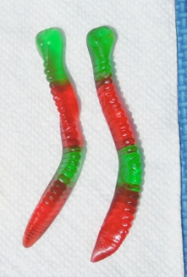
Reasoning: Only one parent’s chromosomes are represented.

After DNA synthesis has occurred:
Common incorrect arrangements:
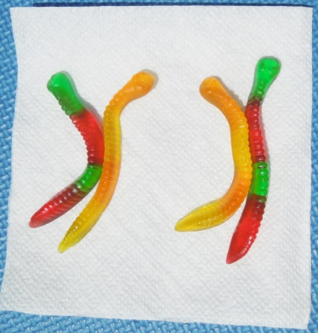
Reasoning: The maternal chromosome can only replicate itself (same for paternal chromosome). This shows a mix of chromosomes, not replicated chromosomes.
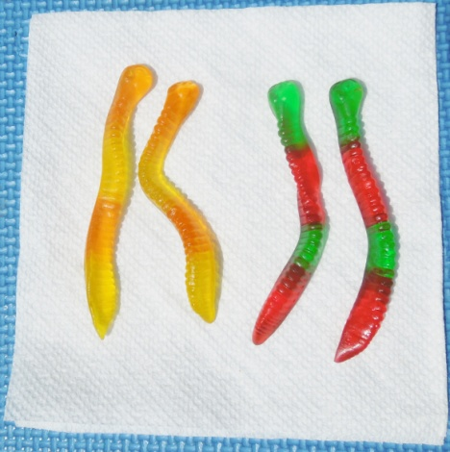
Reasoning: Chromatids are not connected at the centromere.

As the cell prepares for metaphase 1 (vertical crease represents metaphase plate):
Common incorrect arrangements:
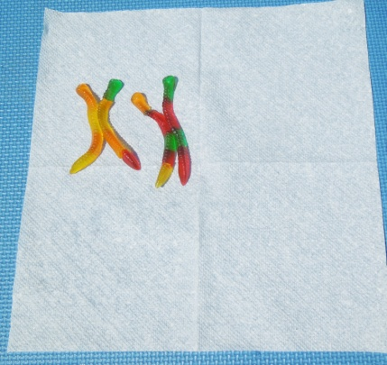
Reasoning: Chromosomes are not lined up on the metaphase plate.

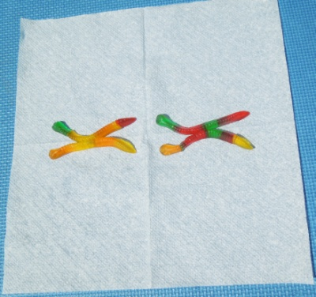
Reasoning: Homologs are not lined up along the metaphase plate. When separated, the resultant cells will not have complete chromosome sets.

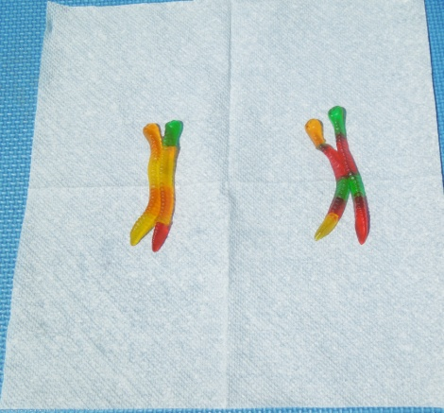
Reasoning: Homologous pairs will not split evenly at meiosis 1, and spindle not likely to attach properly.

As the cell prepares for metaphase 2 (vertical crease represents metaphase plate):
Common incorrect arrangement:
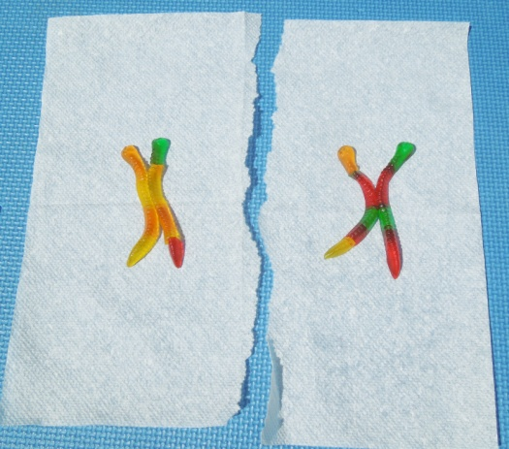
Reasoning: Sister chromatids are not lined up along the metaphase plate. When separated, the resultant cells will not have complete chromosome sets.

