Natural Selection in Fruit Flies
LAB 1

The fruit flies on your lab bench are Drosophila melanogaster. D. melanogaster is a human commensal that is found worldwide. Probably many of the fruit flies you’ve seen in the produce section of the grocery store or around fruit in your home have been D. melanogaster.

Each pair of students has a vial of four female flies and a vial of five male flies. You will be adding your male flies to the vial of female flies (wait until your instructor tells you to!!) and then in a few months, you will be analyzing the population after 4 (or 3) generations.
- Describe the process of evolution by natural selection.

- Look at the vials of males you have. What very obvious physical difference can you see between one of the males and all the other flies?

- If the red-eyed fly’s phenotype confers higher fitness than the phenotype of the rest of the males in the existing population, what do you think will happen to these phenotypes over the course of several generations?

- What about if the red-eyed fly’s phenotype confers lower fitness?

Now, move your male flies into the vial of female flies. To do this, first, hold both vials in one hand and firmly tap the vials on the pad in front of you (not directly on the lab bench, and not so hard that you’re in danger of breaking the vials). Next, while continuing to tap the vials, loosen and remove the cotton of both vials. Then, quickly turn over the vial of males on top of the vial of females and tap them down into the vial of females. While still tapping gently, slip the cotton plug back into the opening of the vial with the flies. You may need to tap the vials on the pad again repeatedly to knock the flies back down to the bottom.

Finally, you need to label the vial that now holds all of your flies (so you can get their descendants back in 3-4 generations). On a piece of white tape write your section number, your instructor’s name, and the names of the two students in your lab group.

- Watch the vial for a few minutes- does anything happen? Leave the vial alone while sitting on its side, then observe again after 10 or more minutes – is anything happening now?

Natural Selection in Fruit Flies
LAB 2

Today we are going to look at the offspring of the flies you put together to mate last time.

Instructions:
1- Use Fly-Nap to put flies to sleep.
- To begin, dip a wand into Fly-nap and insert it into your vial of flies.
- Do not touch the Fly-nap wand directly to the flies or to the food medium, and be careful not to let any flies escape.
Keep the vial on its side for 3-5 minutes with the wand against the side that is up (see image below). The flies should land on the glass side of the vial as they become unconscious. If the vial is left upright, the flies will become stuck in the food medium and it will be difficult or impossible to remove them for sorting.

2- Dump out your flies onto a white piece of paper. Do not throw away the Fly-Nap wand! It should be returned to the tube it started in.
3- With a magnifying glass, separate the males from the females. Record the eye color and sex the flies in the table below.

White-eyed females | White-eyed males | Red-eyed females | Red-eyed males

- How is eye color inherited in Drosophila melanogaster? Use the Punnett Square below to explain your answer.

Natural Selection in Fruit Flies
LAB 3

Goals:

- Assess the mode of phenotypic evolution in your generation 4 (or 3) flies
- Learn about how scientists study molecular evolution using “markers”
- Prepare your flies for DNA extraction
- Conduct a PCR (Polymerase Chain Reaction) using two primer combinations. These PCRs will amplify a particular segment- one pair amplifies a segment near the eye color gene, while another amplifies a segment far away but on the same chromosome (X)

Background:
The Polymerase Chain Reaction (PCR): Cloning DNA in the Test Tube

The polymerase chain reaction is a technique for quickly "cloning" a particular piece of DNA in the test tube (rather than in living cells like E. coli). Thanks to this procedure, one can make virtually unlimited copies of a single DNA molecule even though it is initially present in a mixture containing many different DNA molecules.

The procedure:

- To perform PCR, you must know at least a portion of the sequence of the DNA molecule that you wish to replicate.
- You must then synthesize primers: short oligonucleotides (containing about two dozen nucleotides) that are precisely complementary to the sequence of DNA you wish to amplify.
- The DNA sample is heated to separate its strands and mixed with the primers.
- If the primers find their complementary sequences in the DNA, they bind to them.
- Synthesis begins (as always 5' -> 3') using the original strand as the template.
- The reaction mixture must contain
- All four deoxynucleotide triphosphates (dATP, dCTP, dGTP, dTTP)
- DNA polymerase. It helps to use a DNA polymerase that is not denatured by the high temperature needed to separate the DNA strands.
- Polymerization continues until each newly-synthesized strand has proceeded far enough to contain the site recognized by the other primer.
- Now you have two DNA molecules identical to the original molecule.
- You take these two molecules, heat them to separate their strands, and repeat the process.
- Each cycle doubles the number of DNA molecules.

Using automated equipment, each cycle of replication can be completed in less than 5 minutes. After 30 cycles (less than 2.5 hours), what began as a single molecule of DNA has been amplified into more than a billion copies (2³⁰ =1.07 x 10⁹). (http://users.rcn.com/jkimball.ma.ultranet/BiologyPages/P/PCR.html)

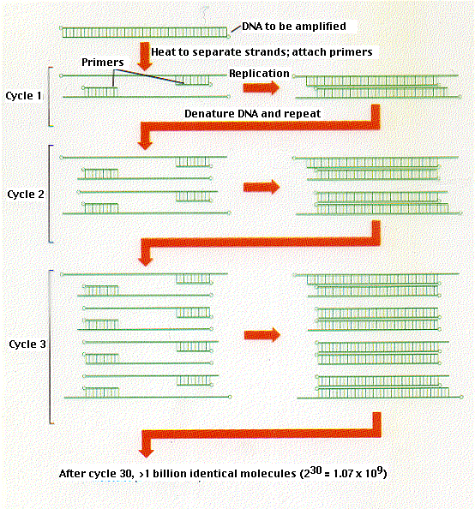
With PCR, it is routinely possible to amplify enough DNA from a single hair follicle for DNA typing. Some workers have successfully amplified DNA from a single sperm cell. The PCR technique has even made it possible to analyze DNA from microscope slides of tissue preserved years before. However, the great sensitivity of PCR makes contamination by extraneous DNA a constant problem.

A description of PCR by its discoverer: http://www.dnalc.org/view/15140-Making-many-DNA-copies-Kary-Mullis.html

Genetic markers
Just like interstate maps have cities and towns that serve as landmarks, genetic maps have landmarks known as genetic markers, or "markers" for short. The term “marker” is used very broadly to describe any observable variation that results from an alteration, or mutation, at a single genetic locus. A marker may be used as one landmark on a map if, in most cases, that stretch of DNA is inherited from parent to child according to the standard rules of inheritance. Markers can be within genes that code for a noticeable physical characteristic such as eye color, or a less noticeable trait such as a disease. Known sequences found within the non-coding regions of genes are used to detect unique regions on a chromosome. DNA markers are especially useful for generating genetic maps when there are occasional, predictable mutations that occur during meiosis that, over many generations, lead to a high degree of variability in the DNA content of the marker from individual to individual. http://people.hsc.edu/faculty-staff/edevlin/edsweb01/courses/genetics/labmanual/quantitative_inheritance.htm

Commonly Used DNA Markers:

- RFLPs, or restriction fragment length polymorphisms, were among the first developed DNA markers. RFLPs are defined by the presence or absence of a specific site, called a restriction site, for a bacterial restriction enzyme. This enzyme breaks apart strands of DNA wherever they contain a certain nucleotide sequence.
- VNTRs, or variable number of tandem repeat polymorphisms, occur in non-coding regions of DNA. This type of marker is defined by the presence of a nucleotide sequence that is repeated several times. In each case, the number of times a sequence is repeated may vary.
- Microsatellite polymorphisms are defined by a variable number of repetitions of a very small number of base pairs within a sequence. The number of repeats for a given microsatellite may differ between individuals, hence the term polymorphism--the existence of different forms within a population.
- SNPs, or single nucleotide polymorphisms, are individual point mutations, or substitutions of a single nucleotide, that do not change the overall length of the DNA sequence in that region. SNPs occur throughout an individual's genome.
Reference: Principles of Biotechnology by Dr. AJ Nair, first edition: 2007, page 670

General Instructions:
- Dispose of used pipette tips in the large beaker labeled “Waste”
- Place all unused flies in the small beaker labeled “Morgue”
- Wear gloves while using chemicals

Using the Pipettors:
- Set the volume within the range specified for the pipette.
- Hold the pipette so the "grippy finger rest" rests on your index finger.
- Check that you are using tips recommended for this pipette.
- Avoid turning the pipette on its side when there is liquid in the tip. Liquid might go to the interior of the pipette and contaminate the pipette.
- Avoid contamination to or from fingers by using the tip ejector and gloves.
- To protect the internal mechanism, always hang the pipettors in their rack when not in use, rather than lying on the lab bench on their sides.

Pipetting technique:
1- Press the operating button to the first stop.
2- Dip the tip into the solution to well below the surface, and slowly release the operating button. Wait 1-2 seconds and withdraw the tip from the liquid, touching it against the edge of the reservoir to remove excess liquid.
3- Dispense the liquid into the receiving vessel by gently pressing the operating button to the first stop and then press the operating button to the second stop. This action will empty the tip. Remove the tip from the vessel, sliding it up the wall of the vessel.
4- Release the operating button to the ready position.

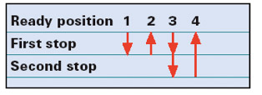
http://www.pipette.com/Images/agtp6.jpg

Part 1: DNA Extraction:

1- Use Fly-Nap to put your Generation 4 (or 3) flies to sleep.
- To begin, dip a wand into Fly-nap and insert it into a fly vial.
- Do not touch the Fly-nap wand directly to the flies or to the food medium, and be careful not to let any flies escape.
- Keep the vial on its side for 3-5 minutes with the wand against the side that is up (see image below). The flies should land on the glass side of the vial as they become unconscious. If the vial is left upright, the flies will become stuck in the food medium and it will be difficult or impossible to remove them for sorting.

2- Using the sample of water on your lab bench, practice using the pipettors by removing and returning liquid to the container with the pipettor. If you are pipetting correctly, there should be no liquid left in the tip after you have dispensed it.
3- Dump out your flies on to a white piece of paper. Do not throw away the Fly-Nap wand! It should be returned to the tube it started in.
4- With a magnifying glass, separate the males from the females. Record the eye color and sex of all flies in the table below.

White-eyed females | White-eyed males | Red-eyed females | Red-eyed males

- What was the frequency of red-eyed flies in the experimental vials before the experiment (when you first put the flies together during the first lab of the semester)?

- If there was no selection on the “red eye” mutation, what would you expect the frequency of the red-eyed phenotype to be now?

- What is the observed frequency of red-eyed flies in the experimental group?

- Did the frequency of the red eyes change? If so, why?

- What is the definition of evolution? Has evolution happened in this fruit fly population?

5- Select 7 male flies from your generation 4 (or 3) offspring, ideally choosing 4 flies of one eye color type and 3 flies of the other eye color type, and label your strip tubes according to the instructions below
- Important! Make sure ALL the tabs are pointing the same direction!
- Use a Sharpie marker.
- On the cap and side of each tube: eye color (red eyes = R, white eyes = W, control = C)
- On the side of tube #1: section number & group number. You are group #______

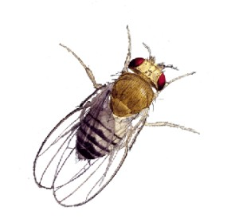
tab
Tube open
Eye color
tab
R

Tube closed
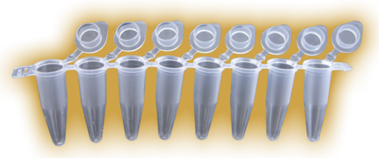
Example:
Control
W W W W R R R C
1-3
Section #
& Group #

- On the schematic below, record the information from the cap of each tube.

1 2 3 4 5 6 7 8
C
6- With a brush or your fingers, place one male fly into each well of the strip tubes (total of 7 flies, one in each of 7 wells – the 8th well is your control), noting the eye color on the schematic below and on the top of the tube. Make sure you have picked a representative sample of your male flies (ie, don’t purposely pick flies of a particular eye color)!
7- Put your strip tubes on ice
8- Keep the Squish Buffer tubes on ice.
9- With the 200 μl pipettor, pick up 30 μl of the Squish Buffer solution and, without ejecting, stab the fly repeatedly with the pipettor tip. You can eject a small amount of liquid to help squish the fly. Be careful not to press too hard – the tube or tip can break!
10-After the fly is squished (~20 seconds, but no more than a minute) eject the remaining liquid over the fly. Repeat for remaining flies, but be sure to change tips between flies- never put a used tip back into the Squish Buffer/pro-K solution.
11-Put 30 μl of the Squish Buffer in the control tube, too (no need to stab since there should not be a fly in this vial).
12- Give the labeled strip tubes containing the fly preps to your TA to put in the thermal cycler to incubate.

Part 2: PCR
1- Label each set of strip tubes according to the instructions below, one set of strip tubes will be for the “NEAR” marker and one set will be for the “FAR” marker.
- Important! Make sure ALL the tabs are pointing the same direction!
- Use a Sharpie marker.
- On the cap and side: marker (N for NEAR or F for FAR) and eye color (R or W or C)
- On the side of tube #1: section number & group number
tab
tab
Tube open
N W

Tube closed
NW NW NW NW NR NR NR NC
1-3
Section #
& Group #

2- Vortex both tubes of master mix.
3- Using a 20 μl pipettor, pipette 19 μl of PCR master mix for the NEAR marker into each strip tube well for the NEAR marker. You can use the same tip for this entire step.
4- Using a different tip, pipette 19 μl of PCR master mix for the FAR marker into each well of your other strip tubes for the FAR marker. You can use the same tip for this entire step, as well, as long as it is a different tip than was used in the step above.
5- Note in this step or the preceding one if you don’t have enough master mix. If that’s the case, then you may not have pipetted correctly. You can still fix it at this point, ask your TA to come over to look.
6- Using the 2 µl or 10 μl pipettor, pipette 1 μl of DNA from your DNA prep strip tubes to your master mix NEAR marker strip tubes. Important: Use a different tip for each DNA prep! Close the lid of the tube after you add a DNA prep sample to remind you which tubes you have already done. Make sure you have labeled everything and know which sample is going into which strip tube well. Double-check that the tubes are capped tightly afterwards.
7- Repeat step 6, putting DNA samples into the master mix for the FAR marker strip tubes.
8- Now the strip tubes will be put in the thermal cycler for the PCR to run. Next week you will perform gel electrophoresis with the resulting samples, photograph the gels, and discuss the images.

- How are scientists able to study evolution molecularly?

- What is the purpose of PCR?

Natural Selection in Fruit Flies
LAB 4

Goals
- Use gel electrophoresis to compare the products of your NEAR and FAR PCRs from last week
- Predict the outcome of your NEAR and FAR PCRs
- Assess what type of evolution has happened at both the NEAR and FAR markers
- Explore the concepts of genetic “hitchhiking” and selective sweeps

Introduction
Electrophoresis is a technique that separates large molecules by size using an applied electrical field and a sieving matrix. DNA, RNA and proteins are the molecules most often studied with this technique; agarose and acrylamide gels are the two most common sieves. The molecules to be separated enter the matrix through a well at one end and are pulled through the matrix when a current is applied across it. The larger molecules get entwined in the matrix and retarded; the smaller molecules wind through the matrix more easily and travel further from the well. Molecules of the same size and charge migrate the same distance from the well and collect into a band. DNA and RNA are negatively charged molecules due to their phosphate backbone, and they naturally travel toward the positive charge at the far end of the gel. They are typically examined with agarose gels.

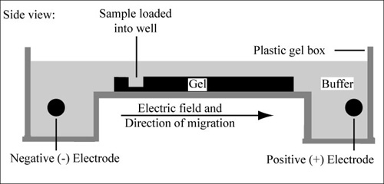
Information from MIT OpenCourseWare: http://ocw.mit.edu/courses/biological-engineering/20-109-laboratory-fundamentals-in-biological-engineering-fall-2007/labs/mod1_2/

Part 1: Gel Electrophoresis

*MAKE SURE TO WEAR GLOVES DURING THIS WHOLE PROCEDURE!!*

Important Tips for Loading the Gel!
- Avoid inserting the tip of the pipettor too far into the well, as it may puncture the bottom of the well and cause your sample to drain out. The end of your pipette tip should not touch the bottom of the well.
- Use a new pipette tip for each sample that you load.
- As you take up your sample into the pipette tip, make sure there are no air bubbles. Air bubbles can cause you to lose your sample in the well, by replacing some or all of your sample in the well with air.
- Inject your sample slowly into the well. When you have completely dispensed your sample, remove the pipettor from the liquid while the plunger is still down. Do not release the plunger until you have raised the pipette tip out of the liquid surrounding the gel. Otherwise, the sample will end up back in the pipette tip instead of the well.
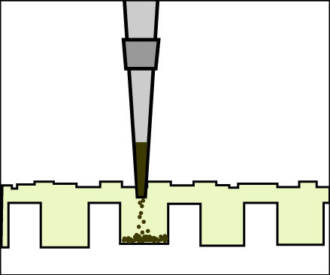
(Figure by MIT OpenCourseWare.)

Gel Loading Practice
1. Loading an agarose gel for the first time can be a little tricky. Practice your gel loading technique with the practice gel dish and practice loading dye located on your bench.

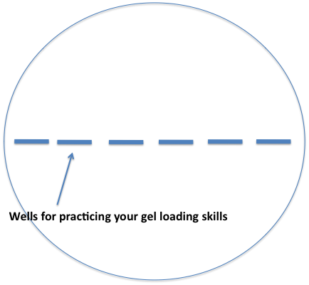

- Take the squirt bottle of water provided and slowly cover the agarose in the Petri dish with water so the wells are filled and there is a thin layer of water covering the agarose.
- Using a P-20 pipettor, pipette 15μl of the blue imitation loading dye into each well in the practice gel.
- When you have finished with your practice dish, please dispose of it by pouring the liquid into the sink and placing the dish in the labeled receptacle provided.

Loading the Gel
2. Pulse spin the 6X loading dye on your bench in the microcentrifuge
- This collects the dye at the bottom of the tube so when you open it, the dye will not be in the lid or around the opening of the tube.
- This will prevent the release of harmful aerosols into the air when you open the cap.

3. Add 4 μl of loading dye to each of your 16 tubes with the P-10 pipettor.
- Make sure to use a new pipette tip each time, so the tube of 6X loading does not get contaminated!
- You should now have 24 μl of volume in each of your samples.
- When you have finished loading all the tubes in a strip, tap the strip of tubes on the bench to knock the dye down to the bottom of the tubes and mix it with your samples.
Note: The loading dye serves two purposes: It contains a hydrophilic, high-mass polysaccharide that causes your samples to sink into the well of the agarose gel, and it contains a dye that will allow us to follow the progression of your samples in the agarose gel. (We don’t want our samples to migrate off the gel because we ran the electrophoresis too long!)

- Using the P-20 pipettor, load 20 µl of each of your samples into a separate well of the 1.8% agarose gel provided, with one well containing 18 µl of the 100-bp ladder loading dye.
- Load the wells from left to right (see the image below). It may help if you hold your strip tubes in the same orientation.
- The ladder goes into the middle well between your NEAR and FAR samples!!
- Be sure to write down the position of each of your samples in the gel (i.e. what lanes they are in, whether they are the NEAR or FAR marker, and whether it was a red- or white-eyed fly) in the spaces provided below.
- Remember that your 8th and 17th samples are negative controls.

- There will be a small amount of sample/dye mixture remaining in your tubes. These strips should be discarded in the biohazard waste receptacle.
START HERE
1 2 3 4 5 6 7 8 9 10 11 12 13 14 15 16 17

LADDER

1 2 3 4 5 6 7 8 9 10 11 12 13 14 15 16 17

___ ___ ___ ___ ___ ___ ___ _C_ _L_ ___ ___ ___ ___ ___ ___ ___ _C_

Run the gel
5. The gel will run at a constant 300V for 45 minutes.
- After 45 minutes, the tracking dye should have migrated to the end of the gel.
Time your gel will be done:____________

Predict your results
- How does the term “variation” apply to this experiment? More specifically, when we talk about variation and/or loss of variation at a marker following a selective sweep, what does that mean?

- For each marker, what changes do you predict will have happened when you compare the initial allele frequencies (from the flies you started with in the first Natural Selection in Fruit Flies lab) to the allele frequencies after four (or three) generations (the flies you extracted DNA from in the third Natural Selection in Fruit Flies lab)?

Document the gel
6. Your TA will turn off the power source and disconnect the electrophoresis cables. Caution: Do not remove the cables yourself!!!
7. After the cables have been removed, remove the top of the gel rig and set aside, right side up.
8. Carefully lift the casting tray containing the gel from the rig and pour off the excess buffer solution into the gel rig.
- Place the casting tray containing the gel into the rectangular tray provided. Label the tray with your section and group numbers.
9. Bring the container with your gel to the camera (your TA will tell you where).
- The prep staff or your TA will take a photo of the gel using an imaging station.
- You will be given a photograph of the gel to analyze.
Note: The gel contains SYBR Safe DNA gel stain instead of ethidium bromide. The health consequences of exposure to SYBER Safe are unknown, so be sure to protect yourself by wearing gloves at all times while working with these gels.

Part 2: Analyze your data:

1- On your gel printout, count the number of gene copies (alleles) that are “high” at the NEAR marker in red-eyed flies, “low” at NEAR marker in red-eyed flies, “high” at the NEAR marker in white-eyed flies, and “low” at the NEAR marker in white-eyed flies (hence, 4 categories). Enter your data in the Final Allele Frequencies table below.
2- Do the same for the FAR marker (another 4 categories) and enter this data in the Final Allele Frequencies table below as well.
3- Combine your data with the data from the other groups in your section to create combined experimental data.

Initial Allele Frequencies
NEAR High: 26.9%
NEAR Low: 67.9%
FAR High: 70.5%
FAR Low: 29.5%
All the red-eyed males that were originally added to the experimental populations had the NEAR High and FAR High alleles.

Final Allele Frequencies
Your data |  | Class data
Red-eyed flies | White-eyed flies | Experimental
NEAR High: | NEAR High: | NEAR High:  Red: White: Total:
NEAR Low: | NEAR Low: | NEAR Low:  Red: White: Total:
FAR High: | FAR High: | FAR High:  Red: White: Total:
FAR Low: | FAR Low: | FAR Low:  Red: White: Total:

- Calculate the overall fractions of “high” vs. “low” at the NEAR marker (don’t worry about eye color now).

- Calculate the overall fractions of “high” vs. “low” at the FAR marker (don’t worry about eye color now).

- Is one of the NEAR alleles “associated” with the red-eyed phenotype at the NEAR marker? One of the FAR alleles? Why or why not?

- After 50 more generations, do you predict both eye color variants will still be found in the population? Both NEAR marker alleles? Both FAR marker alleles? Why or why not?

- In each population, compare the initial allele frequencies of both markers to the final allele frequencies. Did the allele frequencies at the NEAR marker change? At the FAR marker? If both changed, did one change more? Explain.

- Does the data match your prediction? Explain.

- Explain the process that occurred in your populations (in terms of selective sweeps, hitchhiking, and linkage) with respect to the eye color mutation, the NEAR marker, and the FAR marker.

