Workshop: Cellular Reproduction via Mitosis & Meiosis

Introduction
In this workshop you will examine how cells divide, including how they partition their genetic material (DNA) between the two resulting cells. We will consider two different types of cell division: mitosis, which produces the vast majority of cells in a multicellular organism, and meiosis, which is a specialized form of cell division that produces the cells required for sexual reproduction.

Learning Objectives
At the end of this workshop, you should:
- Be able to recognize and sketch the arrangement of chromosomes when attached to the spindle just prior to the chromosome divisions in mitosis and meiosis and to relate these arrangements to the types of cells produced by each process (e.g. either cells that are genetically identical or genetically distinct, and haploid or diploid).
- Be able to explain how mitosis and meiosis relate to the two types of reproduction—asexual and sexual—and to the growth and development of multicellular organisms.
- Be able to define the following terms: diploid, haploid, gametes, somatic cells, germline cells, zygote, fertilization, sister chromatids, and homologous chromosomes.
- Be able to explain how genetic information is recombined during sexual reproduction through the following three processes: independent assortment of homologous chromosomes during meiosis I, crossing over between homologous chromosomes during meiosis I, and fertilization.
- Be able to define the term “chromosome nondisjunction” and to sketch or explain the outcome of nondisjunction when it occurs in each of the following chromosome divisions: meiosis I, meiosis II, and mitosis.

Instructions
Form groups of 3-4 as specified by your instructor. Appoint a group leader who will read the questions aloud to keep the group working together at the same pace. Be sure to allow and encourage all group members to participate. Putting into words what you don’t understand or explaining what you do understand to your teammates is part of this exercise. Your instructor will circulate through the room to answer questions if you get stuck and may stop you at several points to have everyone answer some polling questions to make sure you’re all on the right track. After this class, a key for the workshop questions will be posted. Be sure to check your answers against the key and clarify any discrepancies by reviewing the textbook reading or asking your instructor for further explanation.

Workshop Questions

- From your prior knowledge, define the terms asexual reproduction and sexual reproduction. What’s different about these two processes?

- Asexual reproduction—

- Sexual reproduction—

- Figure 1 below shows a bacterial cell dividing. The term replication means “copying.” Label the step that shows replication of the cell’s genome. (Note: we will consider the details of DNA replication later in the course—for now, you just need to understand that it has to happen before a cell can divide.) Note that the last step in the figure is labeled cytokinesis.
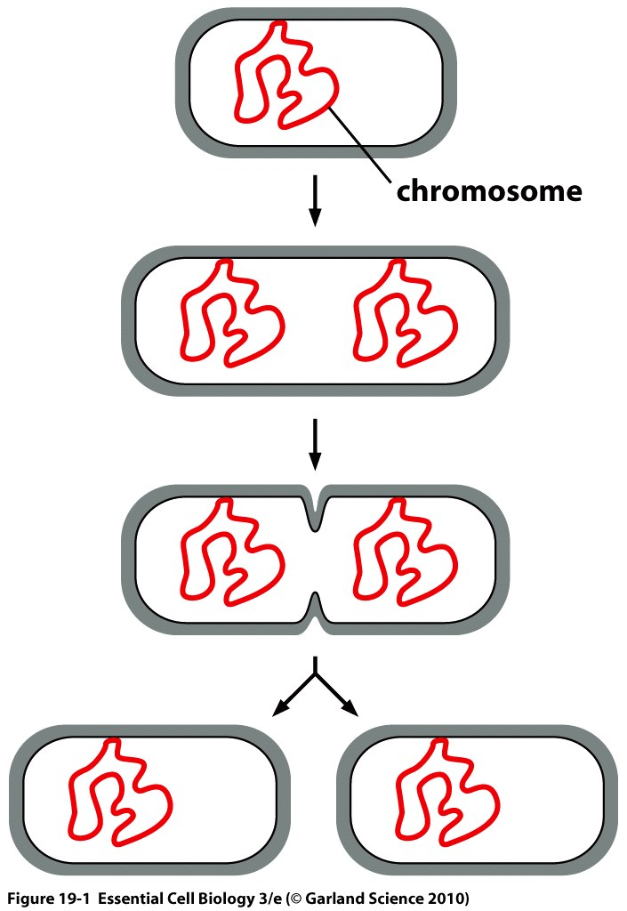
cytokinesis

- Based on what is shown in Figure 1, what do you think the term cytokinesis means?

- Is the cell division shown in Figure 1 an example of sexual or asexual reproduction? What evidence from the figure supports your answer?

Figure 1. Division of a bacterial cell.
Copyright 2013 from Essential Cell Biology, 4th Edition by Alberts et al. Reproduced by permission of Garland Science/Taylor & Francis LLC. (Figure 19-1)

- Figure 2 on the right below shows a multicellular organism called a hydra. The bud will grow larger and eventually detach from the parent organism to live on its own.
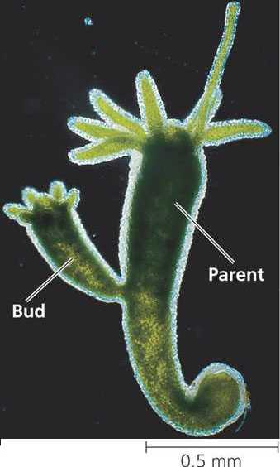
- Is this sexual or asexual reproduction? How do you know?
Figure 2. Budding hydra.
Image from http://science9ldssblock1.wikispaces.com/

- Keeping in mind the focus of this workshop, what do you think has to happen for the buds to grow?

- The DNA that makes up the genomes of most eukaryotic organisms is divided into multiple, linear chromosomes.
- Why would division of a cell with multiple chromosomes be more difficult than the division of the bacterial cell shown in Figure 1, which has a single, circular chromosome?

- Again thinking about the division of a genome into multiple chromosomes, what must occur in order for both daughter cells (i.e. the products of cell division) to end up with the same genetic information?

- Figure 3 below illustrates the key chromosomal event of the cell division process known as mitosis, which is the type of cell division that is used for asexual reproduction. The figure shows three different chromosomes being divided.
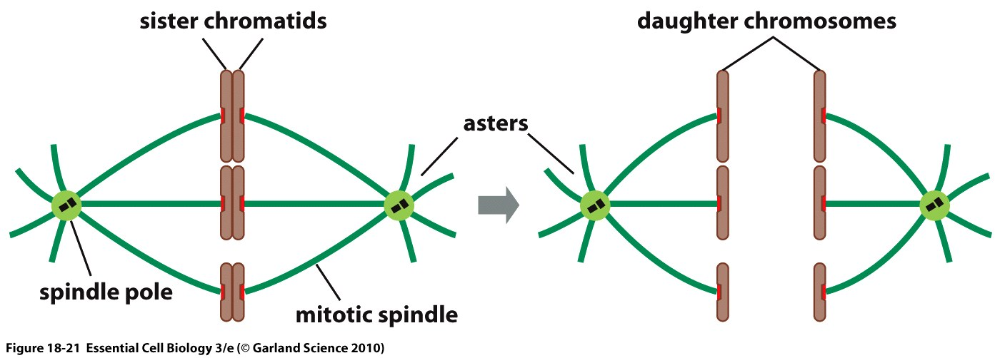
Figure 3. Chromosome division during mitosis. Chromosomes attach to two sunburst-like arrays of fibers located on opposite sides of the cell. This structure is called the mitotic spindle. The spindle fibers are composed of microtubules, one of the elements of the cytoskeleton.
Copyright 2013 from Essential Cell Biology, 4th Edition by Alberts et al. Reproduced by permission of Garland Science/Taylor & Francis LLC. (Figure 18-21)

- Based on what is shown in Figure 3, define the term sister chromatids. What process would have had to occur before the time depicted in the image on the left in order to generate the sister chromatids? (Hint: see #2 above.)

- Judging from what is shown in Figure 3, what is the purpose of the mitotic spindle? How does it solve the problems you identified in Question 4? Note that the microtubules of the spindle are dynamic, in that they can lengthen and shorten; how would this help the spindle accomplish its purpose?

- Two cells that have the same genetic information are referred to as clones of each other. Are the cells that would result from the division shown in Figure 3 clones?

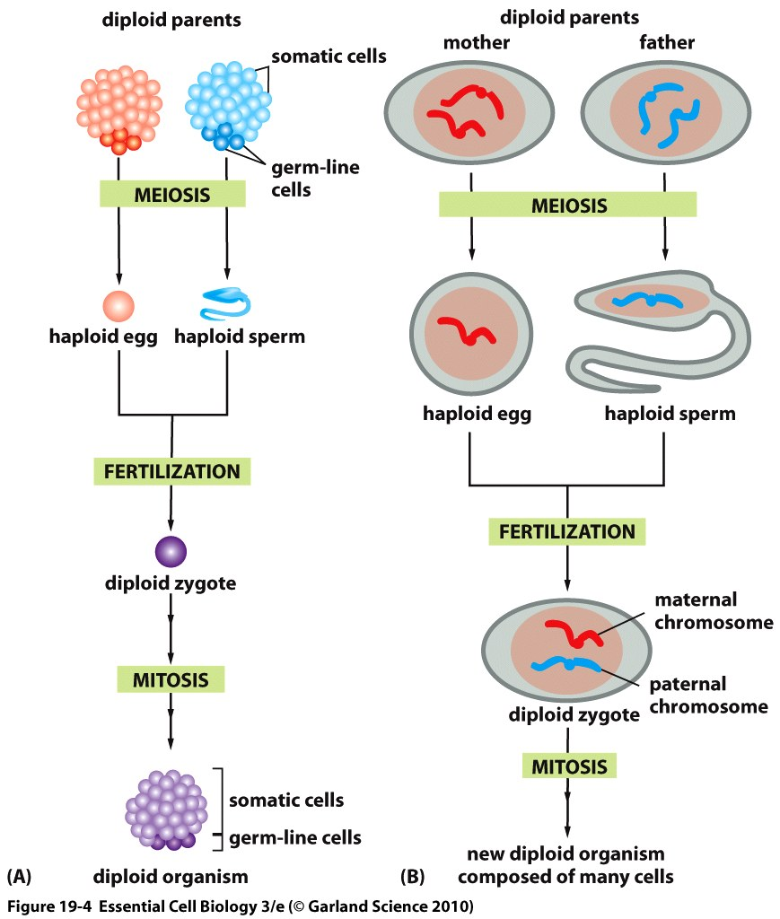
- Figure 4A below shows how the two types of cell division, meiosis and mitosis, relate to the development of an organism that undergoes sexual reproduction. Figure 4B shows what happens to the chromosomes during the processes shown in 4A. Note that the genomes of most eukaryotes are split between multiple distinct chromosomes. For simplicity, Figure 4B represents the genome as only one distinct chromosome, but that chromosome is present in two copies in each of the diploid parents. These two copies are called homologs or homologous chromosomes.
Figure 4. Roles of meiosis and mitosis in the life cycle of an organism that reproduces sexually. A, order of events related to gamete (egg and sperm) production, fertilization, and subsequent development of offspring. Note that most of the cells in an organism are somatic cells; a small number of specialized germline-cells give rise to the gametes. B, behavior of chromosomes during the processes shown in A. The diploid parents contain two copies of the same chromosome (homologs).
Copyright 2013 from Essential Cell Biology, 4th Edition by Alberts et al. Reproduced by permission of Garland Science/Taylor & Francis LLC. (Figure 19-4)

- Based on Figure 4 (figure and legend), which type of cell division (mitosis or meiosis) generates the gametes (egg and sperm) needed for sexual reproduction? Which cells, somatic or germ-line, undergo this type of cell division?

- Which type of cell division (mitosis or meiosis) is responsible for the growth and development of an organism after fertilization?

- Based on Figure 4B, what do the terms diploid and haploid mean?

- Of what ploidy (diploid or haploid) are the end products of meiosis (prior to fertilization)?

- What happens during fertilization? Of what ploidy is the product of fertilization?

- Figure 5 (on page 8) compares the details of chromosome behavior during mitosis and meiosis that were left out of Figure 4B. The entire genome is again represented by one unique chromosome (present in two copies in the starting, diploid cells). Use Figure 5 to answer the following questions.

- How many times does DNA replication occur in each process?
Mitosis: ______ time(s)
Meiosis: ______ time(s)

- How many times does cell division occur in each process?
Mitosis: ______ time(s)
Meiosis: ______ time(s)
- Referring to Figure 5, describe how the two copies of the one distinct chromosome shown in this figure line up on the spindle in mitosis. What is different about the way they line up in the first division of meiosis (meiosis I)?

Mitosis: __________________________________________________________________

Meiosis I: __________________________________________________________________

- On the left side of Figure 5 (meiosis), identify the sister chromatids and the homologous chromosomes. In which meiotic division (I or II) do the sister chromatids separate from each other? In which meiotic division do the homologous chromosomes separate from each other?

- Based on Figure 5, before which meiotic division (I or II) does recombination occur? What happens to the chromosomes during recombination? (Hint: look at the resulting chromosomes shown in the part of the figure labeled Cell Division I. It will be useful to look at the figure in the color handout.)

- Based on Figure 5, how many cells result from a complete cycle of meiosis? Are the cells produced genetically identical or genetically distinct? Explain your answer using support from the figure?

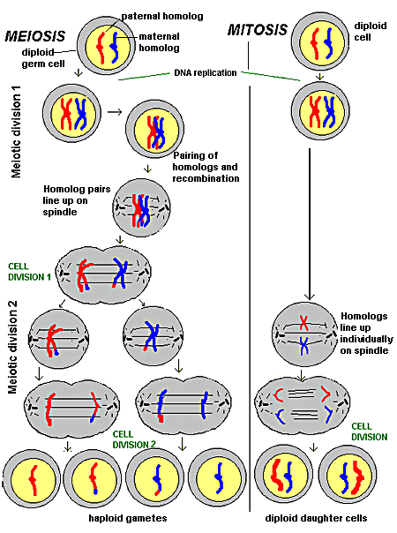
Figure 5. Comparision of chromosome behavior during meiosis (left) & mitosis (right). Note: althought the spindle appears static in this figure, it is actually a dynamic structure that is directly involved in pulling apart the chromosomes (see Question 5b).
Image modified from http://kearnshighscience.wikispaces.com/Comparing+Meiosis+and+Mitosis in accordance with Creative Commons License (http://creativecommons.org/licenses/by-sa/3.0/legalcode)

- Figure 6A and B below illustrate two kinds of reassortment (mixing) of genetic information that both occur during meiosis for a diploid cell that has more than one chromosome pair. It will be useful to look at the figure on the color handout.
- The cell at the top of Figure 6A shows one possible arrangement of three sets of homologous chromosomes. The bottom part of Figure 6A shows eight possible gametes that could result from meiotic division of this cell. Which of the eight gametes could be generated by division of the top cell with the chromosomes arranged as shown (indicate with asterisks)? What would have to be different about the arrangement of the homologous chromosomes in the starting cell to generate the other six gametes? What is the name of this mechanism of reassortment?

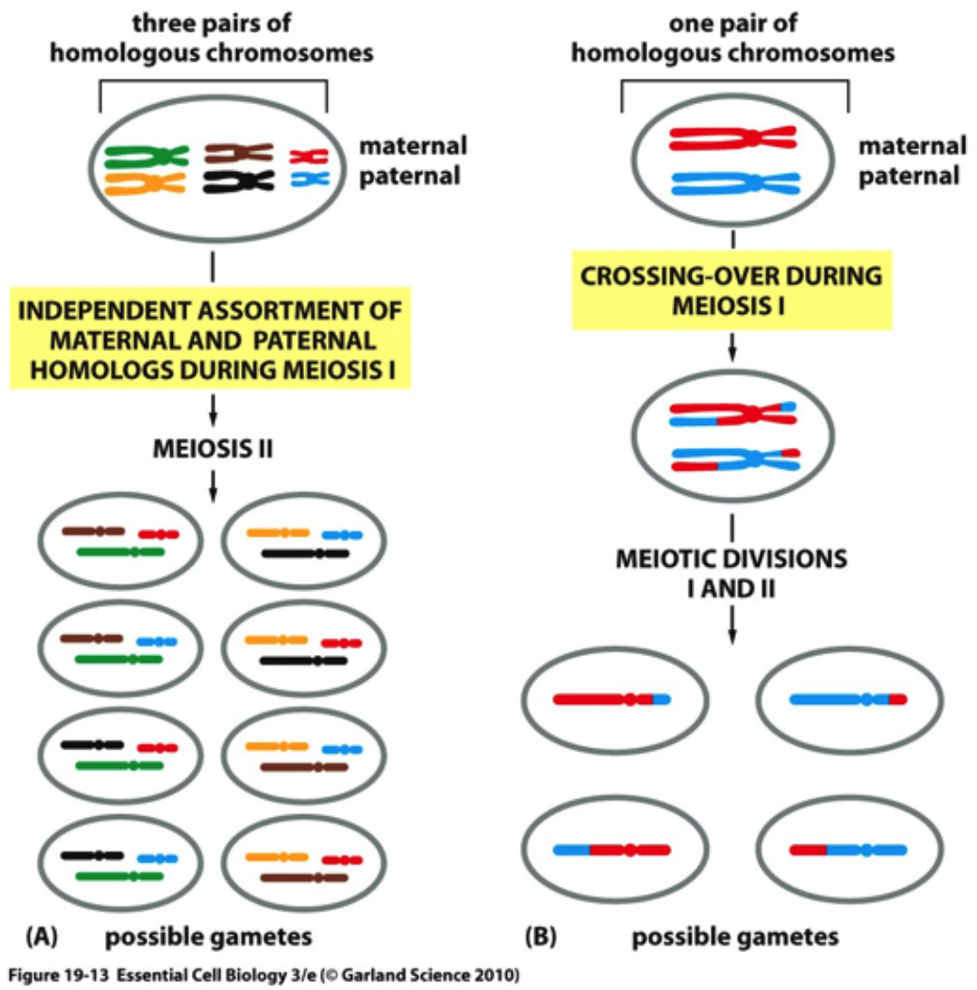
Figure 6. Two types of genetic reassortment during meiosis generate new chromosome combinations.
Copyright 2013 from Essential Cell Biology, 4th Edition by Alberts et al. Reproduced by permission of Garland Science/Taylor & Francis LLC. (Figure 19-13)

- Crossing-over (labeled in Figure 6B) is another word for what term that was introduced previously (in question 7)? What is different about this mechanism of reassortment as compared to the mechanism you identified in Question 8a?

- Figure 7 below illustrates a chromosome nondisjunction event that can sometimes mistakenly occur during meiosis. Such an event related to human chromosome 21 is responsible for Down syndrome. Individuals with Down syndrome have three copies of chromosome 21 instead of the usual two copies.
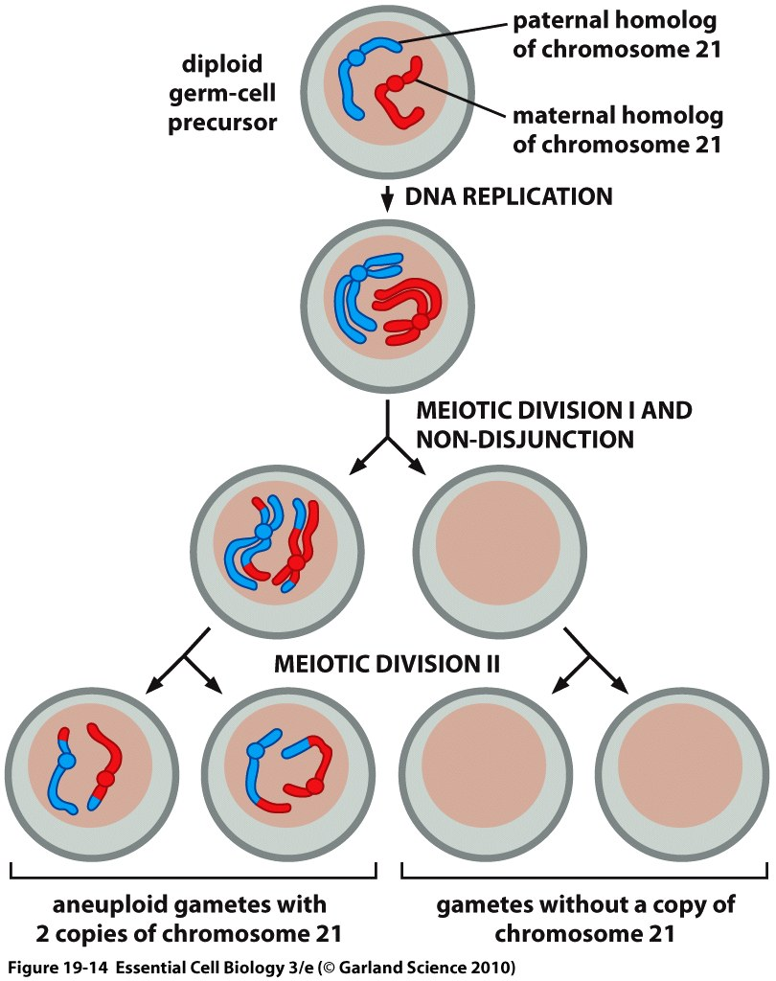
Figure 7. Chromsosome nondisjunction and the generation of aneuploid gametes
Copyright 2013 from Essential Cell Biology, 4th Edition by Alberts et al. Reproduced by permission of Garland Science/Taylor & Francis LLC. (Figure 19-14)

- Based on what is shown in Figure 7, what goes wrong when chromosome nondisjunction occurs? Thinking of the cellular structure responsible for division of chromosomes, hypothesize what causes a nondisjunction event to occur.

- Based on what is shown in Figure 7, what do you think it means for a cell (e.g. a gamete) to be aneuploid? (Hint: think of the terms haploid & diploid).

- Why do individuals with Down syndrome have three copies of chromosome 21? (Only two are shown in Figure 7—where does the third come from?)
Challenge Questions
- Without looking at any of the Workshop figures, draw the arrangement of chromosomes just before division in mitosis, meiosis I, and meiosis II for a diploid cell with its genome divided between two distinct chromosomes.

- Figure 7 illustrate chromosome nondisjunction in meiosis I. Given what you hypothesized to be the cause of that nondisjunction (Question 9a), do you expect that nondisjunction could also occur in mitosis and meiosis II? If so, what would the products of those abnormal divisions look like?

