Workshop: Protein Structure

Introduction
In this workshop you will examine in detail the structures of proteins, from their amino acid building blocks to their fully folded, functional forms. In particular, you will be introduced to the chemical bonding interactions that stabilize the various levels of protein structure. As expressed in the Central Dogma of Biology (“DNA makes RNA makes protein”), proteins are the final products of gene expression for most genes. The physical structure of a protein is intimately tied to its function in the cell. Therefore, a thorough knowledge of protein structure is critical for understanding how genetic information is translated into the functional machinery of the cell.

Learning Objectives
At the end of this workshop, you should:
- Know the basic structure of an amino acid and be able to identify the α-carbon, amino group, carboxyl group, and R group.

- Be able to use rules that you develop in the workshop to categorize the 20 naturally occurring amino acids according to chemical character (nonpolar, polar, acidic, or basic) if shown their structures.
- Be able to identify a peptide bond in a series of linked amino acids or draw two amino acids joined by a peptide bond if shown their individual structures and to identify the N-terminus (amino-terminus) and C- terminus (carboxyl-terminus) of a peptide.
- Be able to describe the four levels of protein structure (primary, secondary, tertiary, and quaternary), what types of bonding interactions hold each level together, and how a protein’s structure relates to its cellular function.
- Be able to link the chemical structures of amino acid R groups to the types of interactions they could form in the folded structure of a protein and to hypothesize the likely consequence of a mutation that swaps one amino acid for another.
- Be able to recognize secondary structure elements when proteins are represented in different ways (e.g. ball-and-stick structures, ribbon diagrams).

Instructions
Forms groups of 3-4 as specified by your instructor. Appoint a group leader who will read the questions aloud to keep the group working together at the same pace. Be sure to allow and encourage all group members to participate. Putting into words what you don’t understand or explaining what you do understand to your teammates is part of this exercise. Your instructor will circulate through the room to answer questions if you get stuck and may stop you at several points to have everyone answer some polling questions to make sure you’re all on the right track. After this class, a key for the workshop questions will be posted. Be sure to check your answers against the key and clarify any discrepancies by reviewing the textbook reading or asking your instructor for further explanation.

Structure & Chemical Character of Amino Acids

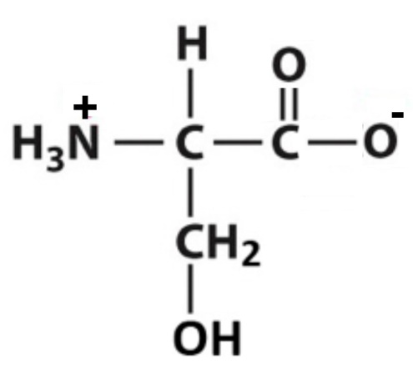
  - Figure A.1 below shows one of the 20 amino acids that make up proteins. Recall that carbon can form four covalent bonds. Amino acids consist of a central carbon, called the α-carbon, that is bonded to four different chemical groups.

Figure A.1. One of the 20 naturally-occurring amino acids.

    - On the amino acid shown in Figure A.1, label the α-carbon.

    - The α-carbon of each of the 20 amino acids is bonded to one hydrogen atom, one amino group, and one carboxyl group. You should recognize the latter two from our discussion of functional groups in organic molecules. Circle and label the amino group and the carboxyl group in Figure A.1.

    - The last bond an α-carbon in an amino acid makes is to an R group, or side-chain. Circle and label the R group in Figure A.1.

  - The last page of this handout (Appendix A) shows the structures of all 20 amino acids. They are categorized into 4 chemical groups: nonpolar, uncharged polar, acidic, and basic. (You may detach the last page for easier access when answering the questions below.)

    - What is the only thing that is different about each of the 20 amino acids?

    - Refer back to Figure A.1. Using Appendix A, determine which amino acid is the one shown in this figure.
To which chemical category does this amino acid belong?

    - Refer again to the amino acid structures in Appendix A. Look at the amino acids in each of the four groups and compare them to the ones in the other groups. Devise rules that describe what the members of each group have in common so that you will be able to identify the chemical group for each of the 20 amino acids if you are shown its structure. Record your rules in the table below.

Chemical Group | Rule Describing Membership in this Group

Peptide Bond Formation

Figure B.1 below shows two amino acids and those same two amino acids after they have been linked together by a peptide bond to form a dipeptide. Addition of more amino acids all linked by peptide bonds would form a polypeptide, the precursor to a functional protein.

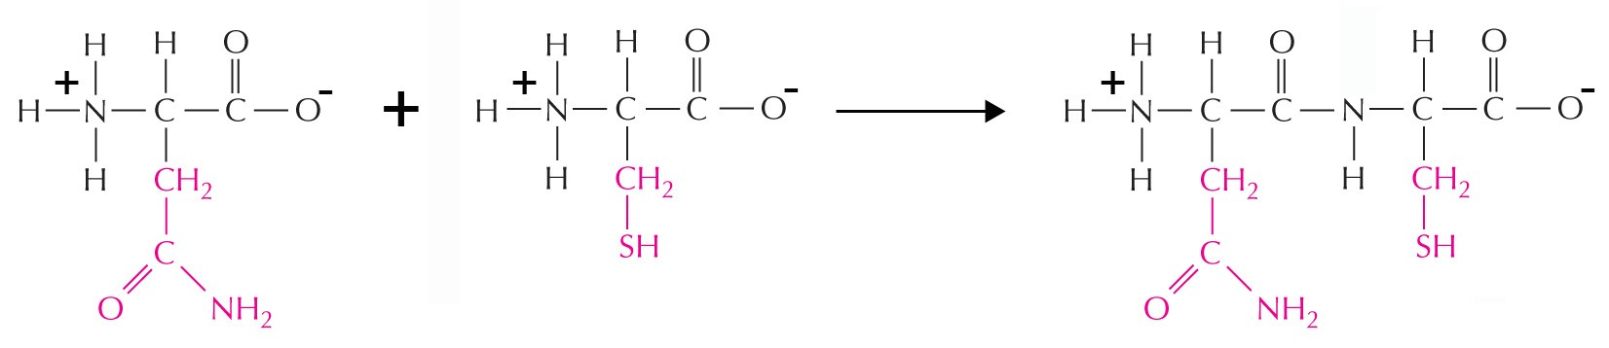

Figure B.1. Formation of a peptide bond between two amino acids.

- Referring again to Appendix A, which two amino acids are the ones shown on the left in Figure B.1 above?
To which chemical groups do they belong?

- On the dipeptide shown in Figure B.1, label the peptide bond that was formed when the two individual amino acids were joined. Also label the free amino and carboxyl groups at the ends of this dipeptide (not in the R groups). These are often referred to as the N-terminus (amino-terminus) and the C-terminus (carboxyl-terminus) of a peptide or polypeptide. (Note: “peptide” refers to a chain of a small number of amino acids, whereas “polypeptide” refers to a longer chain, potentially that corresponding to an entire protein.)

- Look carefully at the chemical reaction shown in Figure B.1. Which atoms that are part of the two individual amino acids on the left are no longer present in the dipeptide on the right? Circle these on the molecules on the left side. Another molecule that is not shown on the right is also a product of this chemical reaction. What molecule do you think this is? (Hint: remember the type of chemical reaction involved in forming macromolecular polymers.)

Levels of Protein Structure

We can distinguish four distinct organizational levels in the three-dimensional structures of proteins, which are referred to as the primary, secondary, tertiary, and quaternary structures. The questions in this section (which begin on the next page) will help you understand the differences between these organizational levels and the types of chemical interactions that hold them together.

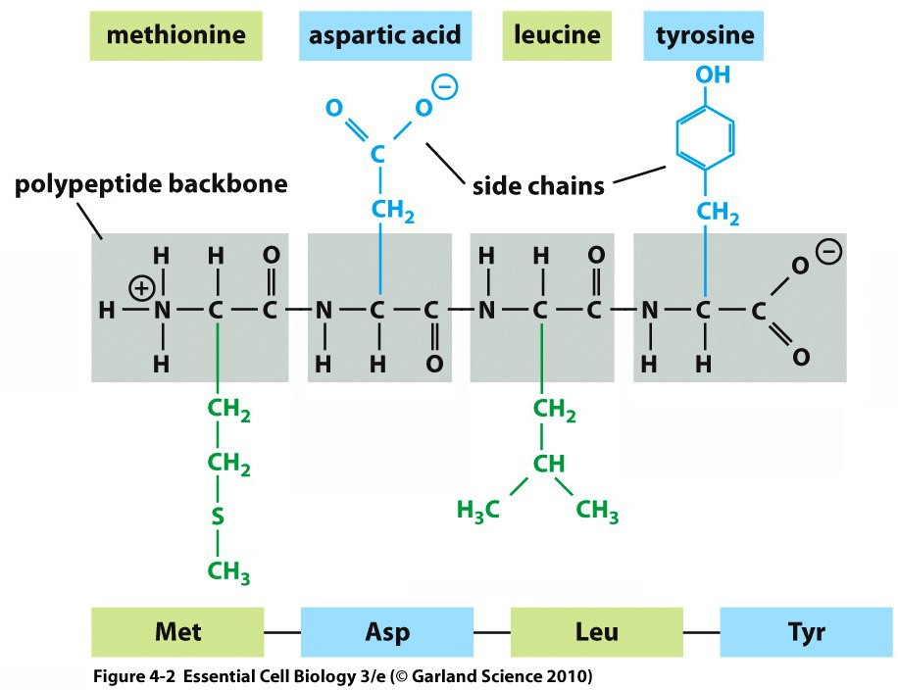

Figure C.1. A four-amino acid peptide. The chemical structure of the peptide is shown with the full names of the amino acids above and their three-letter abbreviations below.
Copyright 2013 from Essential Cell Biology, 4th Edition by Alberts et al. Reproduced by permission of Garland
Science/Taylor & Francis LLC. (Figure 4-2)

- The primary sequence (or primary structure) of a protein is simply the linear sequence of amino acids in the polypeptide chain. Figure C.1 above illustrates a peptide consisting of four amino acids. The full names and three-letter abbreviations for these amino acids are shown at the top and the bottom of the figure, respectively. If you were listing the primary sequence of this peptide using the three-letter abbreviations, it would be: Met-Asp-Leu-Tyr.

  - Looking at the peptide structure shown in Figure C.1, are the primary sequences of proteins listed from N-to-C-terminus or C-to-N-terminus?

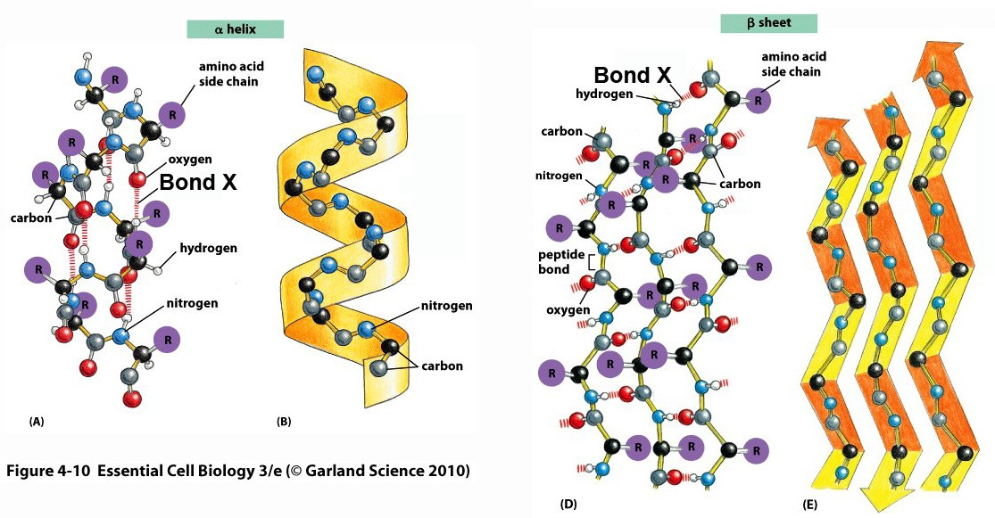
  - Fill in the blanks in the following sentence:

In the primary structure of a protein, amino acids are joined together by bonds, which are a particular type of bond.

- In a folded protein, segments of the polypeptide typically fold into one of two regular patterns that we call secondary structures. These two patterns are illustrated in Figure C.2 below.

A B

C D

Figure C.2. Two types of secondary structure in proteins: α-helix and β-sheet (constructed from multiple β- strands). A & B, α-helix structure represented in ball-and-stick (A) and ribbon (B) forms. C & D, β-sheet structure represented similarly.
Copyright 2013 from Essential Cell Biology, 4th Edition by Alberts et al. Reproduced by permission of Garland
Science/Taylor & Francis LLC. (Figure 4-10)

- The hatched lines connecting atoms in Figure C.2 represent the bonds that hold together these secondary structures (e.g. the one labeled “Bond X”). What types of bonds are these? (I know it’s hard to see—the bonds are between an oxygen and a hydrogen atom.)

- Do the “Bond X” bonds in Figure C2 involve atoms in the amino acid R groups or polypeptide “backbone” (or “main chain”) atoms?

- Given your answer to “b,” which of the following statements do you think is correct? Explain your reasoning.

Only very specific primary sequences can form α-helices and β-sheets.

Many different primary sequences can form α-helices and β-sheets.

- Suppose that the first amino acid in an α-helix is designated “n.” An atom from that amino acid will form a “Bond X” bond with an atom from which of the following amino acids? (It will be very useful to look at the colored version of Figure C2 when trying to answer this question!)

The n+1 amino acid in the chain

The n+2 amino acid in the chain

The n+3 amino acid in the chain

- Each arrow depicted in Figure C.2, panel D represents consecutive amino acids in the primary sequence of the polypeptide, while the different arrows may be formed from amino acids that are removed from each other in the primary sequence. Each arrow is referred to as a β-strand and the structure formed through interaction of the β-strands is the β-sheet. In a complete protein, other segments of the protein would connect the different β-strands. Do the “Bond X” bonds in the β-sheet connect atoms from the same β-strand or neighboring strands?

- Figure C.3 below shows three examples of how secondary structure elements can be arranged in relation to one another in the functional, folded form of a complete protein or one compact portion of a protein (which we refer to as a domain—note that proteins can consist of more than one domain).

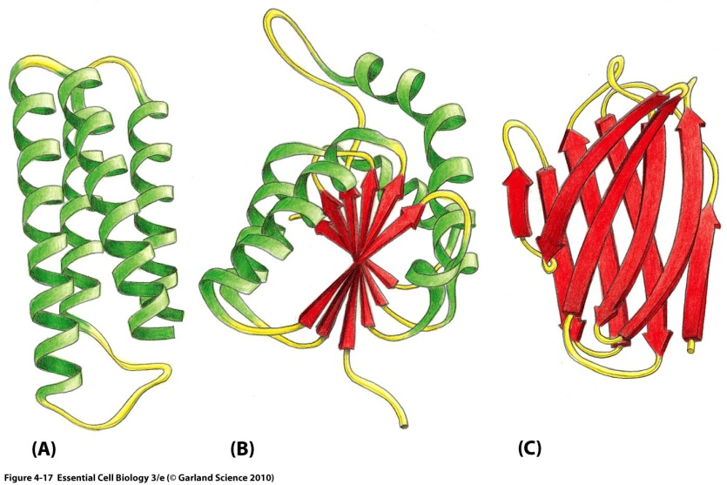

Figure C.3. Examples of the arrangement of α-helices and β-sheets in folded protein domains. Copyright 2013 from Essential Cell Biology, 4th Edition by Alberts et al. Reproduced by permission of Garland Science/Taylor & Francis LLC. (Figure 4-17)

  - We refer to the overall three-dimensional shape (or conformation) of a protein (as shown in Figure C.3) as its tertiary structure. What do you think holds together the various secondary structural elements in a particular three-dimensional pattern? (Hint: think beyond the polypeptide backbone represented by the ribbon diagrams in Figure 5—what is sticking out from the sides of the α-helices and β-strands?)

  - Figure C.4 on the next page shows examples of bonds that might stabilize the tertiary structure of a protein (labeled A, B, and C). Do these interactions involve only the amino acid R groups, only the polypeptide backbone atoms, or both?

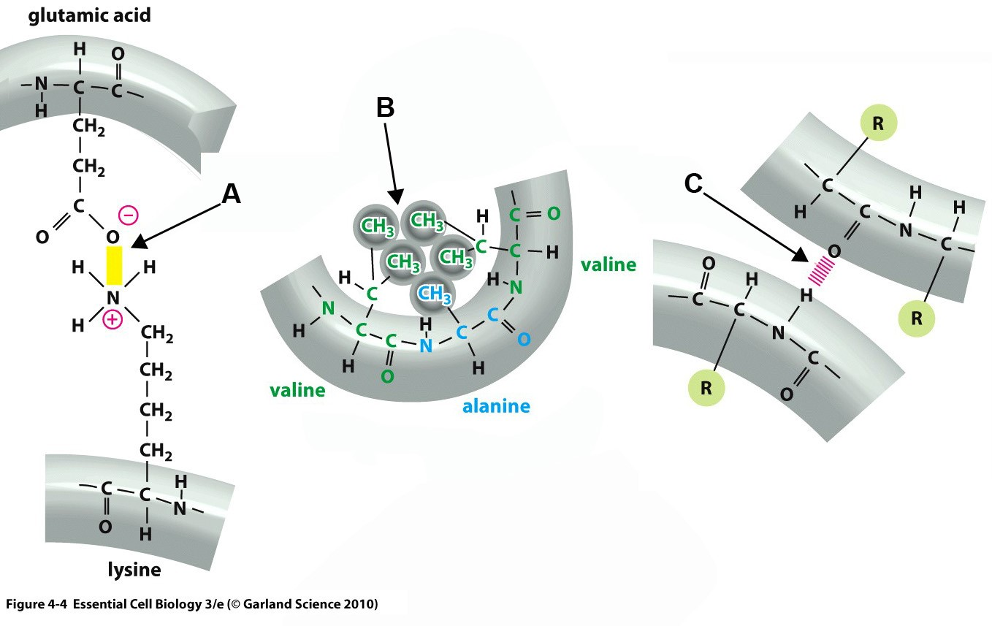

Figure C.4. Three examples of bonding interactions that stabilize the tertiary structures of proteins (indicated by arrows A, B, and C).
Copyright 2013 from Essential Cell Biology, 4th Edition by Alberts et al. Reproduced by permission of Garland
Science/Taylor & Francis LLC. (Figure 4-4)

  - In the table below, indicate what type of bond/interaction is represented in the examples shown in Figure C.4, panels A, B, and C and whether each interaction involves R group or backbone atoms.

Example | Type of Bonding Interaction | R group or backbone?
A
B
C

  - From what you have seen so far regarding the types of interactions that stabilize the tertiary structure of proteins, is the ability to form a particular tertiary structure likely to depend on the primary sequence of a polypeptide more, less, or to the same degree as the ability to form the two types of secondary structures? Explain your answer.

  - Figure C.5 below shows one additional type of bond that can stabilize the tertiary structure of a protein.
This bond is called a disulfide bond (or disulfide bridge), and it involves the sufhydryl (-SH) R groups from one particular type of amino acid. A disulfide bond can form only under certain conditions (oxidative conditions). We’ll talk about oxidation and reduction later in the course; for now, just note that this type of bond does exist in some proteins.

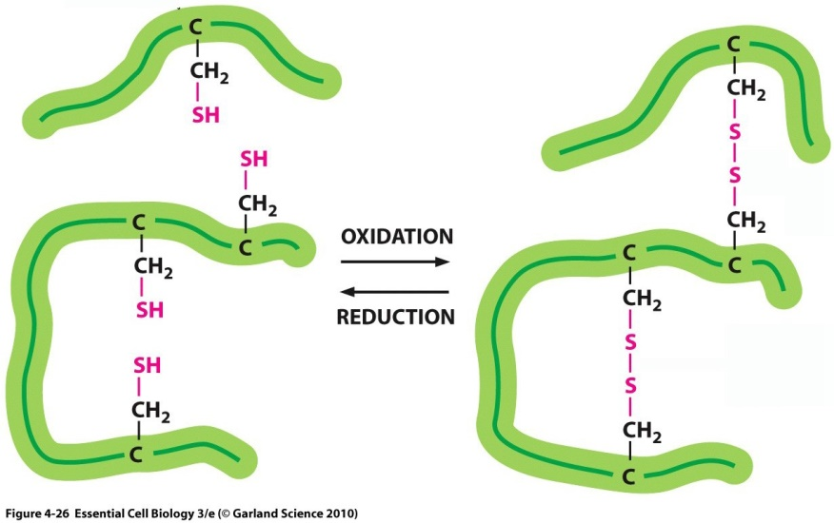

Figure C.5. Disulfide bonds within proteins can form (left-pointing arrow) or be broken (right- pointing arrow), depending on their chemical surroundings (oxidative or reducing). Copyright 2013 from Essential Cell Biology, 4th Edition by Alberts et al. Reproduced by permission of Garland Science/Taylor & Francis LLC. (Figure 4-26)

- Referring again to Appendix A, which amino acid is the one that can form disulfide bonds?

- What is different about the disulfide bond compared to the other types of bonds that stabilize tertiary structure? Based on your existing knowledge of bonding, is this bond weaker or stronger than the other types of bonds?

- One final level of structure exists for some, but not all, proteins. This is called quaternary structure.
Proteins that have quaternary structure are formed from two or more polypeptides that assemble into one active structure. The different polypeptides in a protein with quaternary structure are often called subunits. These subunits may be identical or different. One example of a protein with quaternary structure is hemoglobin, the protein that transports oxygen in our blood. The structure of hemoglobin is shown in Figure C.6 below.
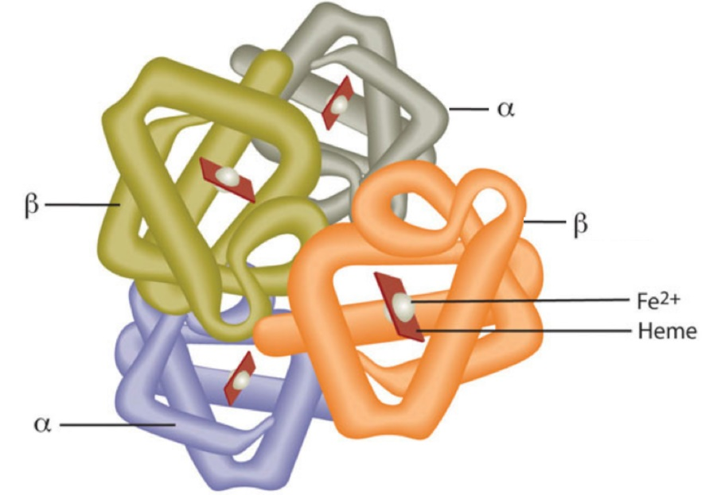

Figure C.6. Quaternary structure of hemoglobin with labeled subunits. Each subunit contains one non- protein heme group complexed to an oxidized iron atom (Fe2+ ); these “prosthetic groups” are required for carrying oxygen in the blood.
Modified from http://2012books.lardbucket.org/books/an-introduction-to-nutrition/s14-04-minerals-important-for- metabol.html under Creative Commons license (http://creativecommons.org/licenses/by-sa/3.0/legalcode)

  - Based on your interpretation of Figure C.6, how many subunits does hemoglobin contain? Are they all the same or different?

  - Which types of interactions do you think stabilize the quaternary structure of proteins that have this level of structure? (Hint: is this any different from tertiary structure, except for the fact that multiple polypeptides are involved?)

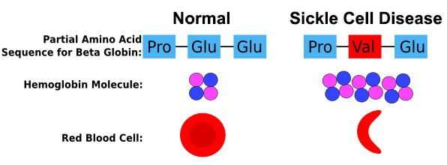

Figure C.7. Changes to the Beta-Globin subunit of hemoglobin in sickle cell disease and the functional consequence for red blood cells.
Image modified from https://beyondthedish.wordpress.com/tag/sickle-cell-disease/
in accordance with Creative Commons License (http://creativecommons.org/licenses/by-sa/3.0/legalcode).

  - Figure C.7 above illustrates the basis of the most common version of sickle cell disease. Keeping in mind what you already learned from Figure C.6, which levels of hemoglobin protein structure are altered in sickle cell disease, as shown in Figure C.7? Explain your answer.

  - Normal red blood cells can easily travel through blood vessels, whereas sickle-shaped red blood cells get stuck. This is the basis of sickle cell anemia. What does this tell you about the relationship between the structure of a protein and its function in a cell/organism?

Appendix A: Structures of the 20 naturally occurring amino acids

