Student Laboratory Manual
Background
The differential ability to taste PTC (Phenylthiocarbamide) was accidentally discovered in the early 1930s by Dr. Arthur L. Fox. The history of this discovery is retold in Wooding (2006). Dr. Fox had synthesized PTC and was transferring the substance into a bottle when a co-worker complained about the bitter taste of the dust. Fox himself tasted nothing. Further investigation determined that PTC taste ability is a dominant trait in humans and this discovery has led to over 80 years of research on the genetics of taste variability. Kim et al. (2003) determined that the TAS2R38 bitter taste receptor gene on chromosome 7 is responsible for the ability to taste PTC and identified three common single nucleotide polymorphisms (SNPs) associated with PTC taste sensibility (C/G 145, C/T 785, G/A 886). The first SNP at base 145 is associated with 85% of PTC taste ability and encodes for proline (taster) or alanine (non-taster) at amino acid 49. In the USA, 70-75% of people are tasters. Interestingly the ability to taste PTC can vary up to 5 orders of magnitude (Blakeslee, 1932).
The ability to taste PTC is correlated to the presence of a thiourea moiety (N-C=S) within the compound (Fox, 1932). It is hypothesized that the ability to taste PTC could have a protective advantage by allowing identification of bitter tasting toxic compounds in plants. For example, over-ingestion of certain compounds (goitrogens), in regions with low iodine, is associated with thyroid disease and goiter suggesting PTC sensitivity can play a protective role (VanEtten, 1969; Wooding et al., 2004). However, other foods contain bitter phytochemicals with thiourea moieties that have possible cancer-protective activity and other advantageous health effects, examples are green tea, red wine, cruciferous vegetables and soy products.
Taste is a complicated process. Culture differences, age, desired healthiness and mood can all affect taste perception. There has been increasing interest in PTC sensitivity and the impact on dietary choices (Bufe et al., 2005; Drewnowski et al., 2001; Laaksonen et al., 2013; Sandell & Breslin, 2006). In an interesting twist, there is evidence suggesting that berries from the plant Antidesma busnius found in Southeast Asia and northern Australia are bitter to PTC non-tasters and sweet to tasters (Henkin & Gillis, 1977; Tharp et al., 2005). Recent TAS2R38 protein modeling studies have suggested that the different receptor alleles may bind different ligands with different downstream taste effects (Floriano et al., 2006; Tan et al., 2012). Examination of the molecular evolution of this gene suggests that natural selection has acted to maintain taster and non-taster alleles in humans conferring an advantage to heterozygotes perhaps by increasing the repertoire of bitter toxins that can be detected through the diverse receptors (Wooding et al., 2004).

Experimental Overview
Your ability to taste thiourea-containing compounds will be evaluated by examining both your phenotype and genotype. First, using your self-knowledge of the foods you like and dislike, you will form a testable hypothesis (Taster or Non-taster). Once you have your hypothesis you will determine your genotype by; isolating your genomic DNA (Day 1), PCR amplifying the genetic area of interest using the dCAPs method (Day 2), and using two different methods (restriction enzyme digestion and Sanger sequencing) to generate data for analysis and interpretation (Day 3). You will also directly test your phenotype using PTC taste paper (Day 3). The genotypic data from the class will then be used to perform Hardy-Weinberg Principle analysis to determine if the genetic variation within the class meets expected allelic ratios. (See the Experimental Flow Chart on the following page).

Laboratory Safety:
These labs require students to work with proteinase K, ethidium bromide and UV light. Care should also be taken, using sterile techniques, to avoid contamination of the samples. Use of E-gels significantly reduces the exposure to ethidium bromide. The E-gel waste (ethidium bromide) should be disposed of properly. Cell waste should be disposed of properly. Students should wear lab coats, gloves, and eye protection during these experiments. UV protective shields must be in place when visualizing gels with a UV transilluminator.

Concern about the safety of the PTC tasting strips has been questioned by Texley et al., 2004, however further evaluation by Merrit et al., 2008 compares the toxicity of PTC to common table salt and they state “We calculate that the 230 mg of NaCl (salt) in a vending machine bag of potato chips is about 100 times more toxic than the .007 mg of PTC in a taste paper.” There has been 75 years of PTC research without any evidence of toxicity associated with PTC taste paper (Merritt et al., 2008; Wooding, 2006).

Experimental Flow Chart

Day 1

Day 2

Day 3

Generate Hypothesis
Genomic DNA isolation from buccal (cheek) cells

PCR amplification using dCAPs technology to create a unique HaeIII restriction site in the Taster allele

Sanger sequencing of product

HaeIII restriction digest Sequence analysis
to determine genotype to determine genotype

PTC taste strips
to determine phenotype

Compare all results

Begin Hardy-Weinberg Analysis

NOTE: There are video overviews provided for each of the laboratory periods. Please read the laboratory and view these videos before each laboratory session.
Student Tasting Survey
Please rate on a scale of 1-5 (1 Yum, 2 Like, 3 Neutral, 4 Don’t like, 5 Yuck, N/A unknown).

Consider these flavors as individual foods. Take into consideration whether you have always liked these. Were you a picky kid or are there foods that you have just learned to like?

Grapefruit juice 1 2 3 4 5 N/A
Orange Juice 1 2 3 4 5 N/A
Cabbage 1 2 3 4 5 N/A
Spinach (large- raw) 1 2 3 4 5 N/A
Carrot 1 2 3 4 5 N/A
Coffee – strong/black 1 2 3 4 5 N/A
Turnip 1 2 3 4 5 N/A
Eggplant 1 2 3 4 5 N/A
Brussel sprouts 1 2 3 4 5 N/A
Raw Broccoli 1 2 3 4 5 N/A
Green beans 1 2 3 4 5 N/A
Tofu 1 2 3 4 5 N/A
Potato 1 2 3 4 5 N/A
Red Radish 1 2 3 4 5 N/A
Kale 1 2 3 4 5 N/A
Sprouts (alfalfa) 1 2 3 4 5 N/A

Use the survey information to help form a hypothesis of whether you are phenotypically a “taster” or “non-taster”.

Look at your scores for orange juice, carrots, eggplant, green beans, sprouts, and potatoes crossing them off as you go down the list. – Do you dislike most of these? Perhaps you are a picky eater.

The rest of the foods have been placed on the list based on reports that some tasters find the food bitter and/or due to the known presence of thiourea containing substances within these foods (Drewnowski et al., 2001; Laaksonen et al., 2013; Sandell & Breslin, 2006; Wooding, 2006).

How many of the other 10 items did you score a 4 or a 5? If you have 5 or more you could be a taster.

What is your hypothesis?

If your hypothesis is correct what is/are your possible genotype/s?

Laboratory 1 Overview
In today’s laboratory your genomic DNA will be isolated from buccal (cheek) cells. To isolate the DNA you will need to lyse the cells and digest the proteins surrounding the DNA. The membranes will be lysed with chaotropic salts (see below) and detergents (to disrupt membranes) in the AL buffer (lysis buffer). The proteins will be digested with Proteinase K at 56^{ο}C. Next we will add ethanol to your sample and bind the DNA to a silica membrane contained in a small column (QIAamp Spin Column). Then we will wash the membrane to remove excess salt and other contaminants. Once the membrane is washed we can elute the clean DNA, check its quantity and quality, and determine how much to use in subsequent protocols.

The Silica Column Chemistry - Guanidium hydrochloride is the chaotropic salt found in the LT buffer. Chaotropic salts disrupt the hydrogen bonds between water molecules creating a hydrophobic environment where nucleic acids (DNA/RNA) are less soluble. This promotes nucleic acids to electrostatically bind to the silica through the negatively charged phosphate backbone. A balance of the chaotropic salt, pH, water, and ethanol controls the binding of either RNA or DNA to the silica selecting a majority of one or the other. The use of ethanol in the AL buffer and the wash buffers (AW1 and AW2) maintains the bond between the silica and the DNA while allowing contaminants to pass through. After the wash steps, all of the ethanol is removed from membrane and the DNA can be eluted from the membrane using the aqueous AE buffer.
The following animations are provided for review.
This is the DNeasy visual protocol for genomic DNA isolation. https://www.youtube.com/watch?v=JAj60HTpto0&list=PLnvLJBxB4Ysad30ymWNjwTyAW-gPfNsO&index=13

Closer look at the silica column chemistry https://www.youtube.com/watch?v=SQvjb4vJanQ&list=PLnvLJBxB4Ysad30ymWNjwTyAW-gPfNsO&index=11

Review of inheritance (click through animation): http://www.dnalc.org/resources/genescreen/inheritance.html
Genomic DNA Isolation and Quantitation
Part I: Cheek Cell DNA Isolation (Qiagen, 2012)

___ 1. Thoroughly swab the inside of your cheeks with a sterile cotton swab for 30 sec.

___ 2. Place the swab in a 1.5 ml microfuge tube and break off the end of the swab in order to be able to close the tube.

___ 3. Add 400 μL phosphate buffered saline (PBS) to the tube.

___ 4. Add 400 μL buffer AL to your tube. This is to lyse the cells, releasing the DNA into solution.

___ 5. Add 20 μL proteinase K, close the lid, and immediately vortex for 15 seconds.

___ 6. Incubate for 10 minutes at 56^{ο}C. To digest the proteins in the sample.

___ 7. Add 400 μL of ethanol (96-100%), close the cap, and then vortex for 15 seconds.

___ 8. Apply 700 μL to a QIAamp spin column (in a 2 mL collection tube), close the cap.

___ 9. Centrifuge at 8,000 RPM (6000 x g) for 1 minute. Discard the flow-through in the collection tube. The collection tube can be reused until step 15, the final wash step.

___ 10. Repeat steps 8 and 9 with any remaining mixture from step 7. Your DNA is now bound to the column.

___ 11. Add 500 μL buffer AW1 to the spin column, close the cap. Contains guanidium hydrochloride and ethanol to maintain disruption of DNA hydrogen bonding.

___ 12. Centrifuge at 8,000 RPM for 1 minute, and then discard the flow-through.

___ 13. Add 500 μL buffer AW2 to the spin column, close the cap. Contains ethanol to maintain binding to silica.

___ 14. Centrifuge at full speed (14,000 RPM/20,000 x g) for 3 minutes.

___ 15. Remove the spin column from the collection tube and place in a new one.

___ 16. Centrifuge at full speed for 1 minute. This step is important to remove any residual ethanol.

___ 17. Place the spin column in a new, labeled microfuge tube (label top and side).

___ 18. Add 100 μL buffer AE to the spin column. Here you begin the elution.

___ 19. Incubate at room temperature for 1 minute.

___ 20. Elute the DNA by centrifuging at 8,000 RPM for 1 minute. Your DNA is now in the 1.5ml tube.

___ 21. Remove and discard the spin column.

___ 22. Label the microfuge tube to store the samples in freezer at -20°C.

Part 2: Determining the Quality and Quantity of the Genomic DNA (if time is limited this may be done by your instructor).

The quantity and quality of the genomic DNA sample should be determined using a spectrophotometer (or NanoDrop). Determine the concentration and absorbance ratios (A260/A280) according to your instructor.

Expected concentration for buccal cell DNA isolation using a QIAamp column is 0.5-3.5 ug of genomic DNA (5-35ng/ul). Check your calculations with a classmate.

Expected absorbance ratio (A260/A280) is between 1.7 and 1.9. Notify your instructor if your ratio is different. There may be some salt contamination.

Concentration of sample ________ng/ul

Absorbance ratio _______

Laboratory 2 Overview

In laboratory 1 genomic DNA was isolated from buccal cells. Today you will perform a Polymerase Chain Reaction (PCR) to amplify a 221bp region of the TAS2R38 gene containing the SNP at base 145 (C/G) (Figure 1). SNP 145 in TAS2R38 is primarily responsible for the ability to taste PTC. The TAS2R38 gene is encoded by a single exon allowing the creation of specific PCR primers without the concern of non-coding intron sequence. The PCR product generated today will be used for genotyping using Sanger sequencing (discussed in Lab 3) and restriction enzyme digestion.

Animated reviews of PCR can be found at
http://learn.genetics.utah.edu/content/labs/pcr/ https://www.youtube.com/watch?v=2KoLnIwoZKU
https://www.youtube.com/watch?v=iQsu3Kz9NYo
Restriction enzymes (REs) recognize and cleave distinct DNA sequences. At some SNPs a RE recognition site is present in one allele but not the other. Therefore if you PCR amplify an area around a SNP, the allele with the RE recognition site will be cleaved by the RE generating two smaller DNA products while the other allele will not be cleaved. This allows the differentiation of the two alleles. This technique is called Cleaved Amplified Sequence (CAPS) genotyping. However, not all SNPs have a naturally occurring RE site. This is true for SNP 145 in TAS2R38. In this case we can generate a RE recognition site at the SNP by modifying the sequence of one of the primers. This method is called Derived Cleaved Amplified Sequence (dCAPS) genotyping (Neff et al., 1998). dCAPS introduces a RE recognition site in one allele at the SNP using a modified primer sequence during the PCR amplification (Figure 1). This method can be used for interrogation of any SNP in the genome without a naturally occurring RE recognition site. (You will learn more about REs in lab 3). The PCR reaction is similar to what is reviewed in the animations provided above. The only difference is the incorporation of a one base change in order to introduce the RE recognition site. In this case the RE is HaeIII with the recognition sequence GGCC (see Figure 1 for more specific details).

After thawing the components for the PCR reaction you will assemble a 4X master mix adding each component in the order specified in Table 1. The master mix will be used to set up three PCR reactions. PCR takes advantage of Taq polymerase that can maintain its activity even after exposure to very high temperatures. The 10X reaction buffer contains Mg⁺⁺ necessary for Taq polymerase activity. Other reaction components are the forward and reverse primers, dNTPs and water. After addition of the DNA template the reaction will undergo 30 cycles of denaturation, annealing, and extension to amplify the area of interest. At the end of the amplification a portion of the reaction will be sent for Sanger sequencing as a second method to determine genotype. The RE digestion of the amplified product and analysis of the digest and sequence reactions will be conducted in laboratory 3.

NOTE: When performing a PCR reaction it is very important to avoid contamination of the experimental sample. Any contamination from another source will be amplified if the primers recognize the sequence. In performing PCR reactions for DNA testing, forensics, experimental research etc. two common controls are included. 1) A negative control – this control contains no template DNA and should not generate a product. 2) A positive control – this contains a known positive template and confirms that the PCR enzymes and cycling conditions are accurate for the experiment. This is especially important if you are testing a sample for the presence or absence of a specific nucleotide sequence.

Can you think of a type of PCR experiment where you may be looking for the presence or absence of a PCR product?

Figure 1 dCAPS Method to Amplifying SNP 145 in the TAS2R38 Gene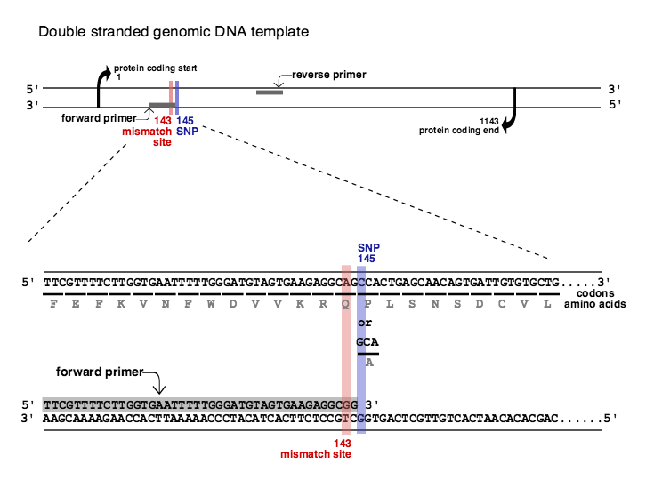
Figure 1 – This PCR reaction utilizes a forward and a reverse primer to amplify a 221bp region of the TAS2R38 gene containing SNP 145. The forward primer is 44 bases long and contains the coding sequence from nucleotides 101-144 except for a mismatch at base 143 (A to a G). The reverse primer is 24 bases long and contains the complimentary strand nucleotides 321- 298. The PCR reaction generates a double stranded DNA product from 101-321. The incorporation of the G nucleotide at base 143 creates a HaeIII restriction site (GGCC) in the taster allele. However, the non-taster allele (GGGC) cannot be cleaved by HaeIII. The amino acid sequence of this region is also shown. The taster allele has a proline encoded at amino acid 49 while the non-taster allele encodes an alanine (P49A).

PCR Amplification of Taste Receptor TAS2R8
____1. Keep the Ex Taq polymerase on ice.

____2. Thaw the other reagents.

____3. Vortex the 10X buffer for 5 seconds after it has thawed.

____4. Prepare the 4X Reaction Master Mix in a 1.5 ml tube (one for each group).
Check off each reagent in the table as it is added.
Make sure to add each reagent in order beginning with the dH₂O

Table 1
Reagent | 1X  Volume, μL | Master Mix 4X Volume, μL
dH₂O | 33.75 | 135
10X buffer | 5 | 20
10 mM dNTP | 4 | 16
F primer (mismatched)  0.5μM (final concentration) | 1 | 4
R primer  0.5μM (final concentration) | 1 | 4
Ex Taq | 0.25 | 1
Template DNA | 5 | *None*
 | 50

____5. Vortex the master mix briefly (5 seconds).

____6. Then centrifuge for 5 seconds.

____7. Add 45 μL of master mix to your individual, labeled 0.2 ml tube.

____7. Add 5 μL of your sample DNA to your labeled 0.2 ml tube.

PCR cycling protocol (This protocol is preprogramed into the thermocycler)

30 cycles of:

Denature 98°C 10 sec
Annealing 58°C 30 sec
Extension 72°C 30 sec

Laboratory 3 Overview
DNA extraction from buccal cells was conducted in laboratory 1. In laboratory 2, a 221 bp region of the TAS2R38 gene was amplified using PCR and a modified primer introduced a restriction site in one allele. Samples of the PCR product were then sent to a core facility for Sanger sequencing. Today you will perform a restriction digest of the 221 bp PCR product with the HaeIII enzyme, which recognizes the sequence GGCC present in one allele (dCAPS). You will conduct gel analysis of the digest and analyze your Sanger sequence results. You will also determine your PTC taste phenotype using PTC taste strips. You will then be able to compare all of your data and using the data from the entire class perform Hardy-Weinberg Principle analysis to examine genotypic frequencies (a worksheet will be provided for you).

An animated review of Sanger sequencing can be found at
https://www.dnalc.org/view/15923-Cycle-sequencing.html
A great review of the Hardy-Weinberg Principle with equation examples can be found at
https://www.youtube.com/watch?v=oG7ob-MtO8c

Restriction endonucleases are enzymes found in Bacteria and Archaea and provide a defense mechanism against invading viruses. Type II REs recognize and cleave DNA at a specific nucleic sequence or “recognition site.” The identification of REs revolutionized molecular biology (reviewed in Roberts, 2005). There are over 2,500 commercially available REs. The HaeIII enzyme will be added to a portion of your PCR product. If the 221bp PCR product contains the taster genotype (GGCC) the HaeIII enzyme will cleave that product generating two fragments of 177bp and 44bp. The non-taster allele (GGGC) will not be digested (Figure 2). The restriction digest products will undergo gel electrophoresis to separate the DNA fragments by molecular weight.

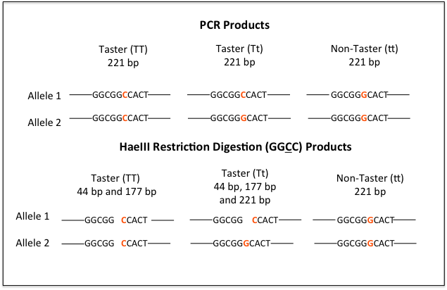
Figure 2 PCR and Restriction Fragments Products

Figure 2 – HaeIII restriction enzyme digestion of the 221bp product will result in 2 fragments
117bp and 44bp, of the taster allele (T) while the non-taster allele (t) will not be cleaved
remaining at 221bp.

Based on your hypothesis and predicted genotypes what size fragments would you expect to see?

Genotype(s)______________________ Fragments ___________________

Sanger sequencing was invented in 1977 (Sanger et al., 1977). This method, also called “dideoxy sequencing,” utilizes di-deoxynucleotides mixed with deoxynucleotides to randomly terminate chain extension during a sequencing reaction. The removal of the -OH in the di-deoxy nucleotide does not allow for the binding of subsequent nucleotides thereby terminating chain extension (Figure 3 box in upper right). The different nucleotides are provided in a ratio where a random termination occurs at each nucleotide during the reaction. Incorporation of different fluorescent dyes into the four di-deoxynucleotides allows for identification of each terminal base (Figure 3, part 2). Separation of the sequence fragments by gel or capillary electrophoresis and excitation of the fluorophore on each terminal dideoxynucleotide is used to generate an electropherogram to determine the DNA sequence.
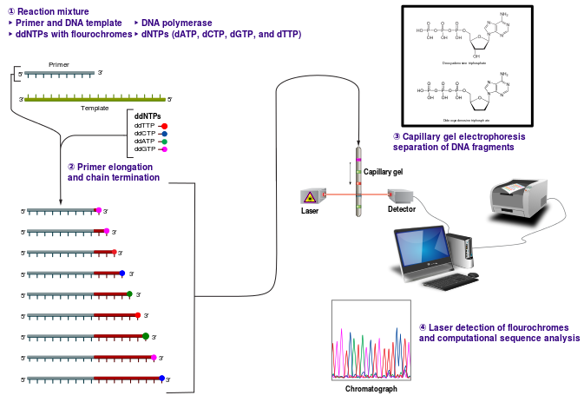
Figure 3 Sanger Sequencing Overview
(https://commons.wikimedia.org/wiki/File:Sanger-sequencing.svg#file)
Figure 3 - 1) The reaction mixture contains both dNTPs and ddNTPs. 2) Termination occurs randomly but each base is represented. 3/4) A laser detects the fluorophore on each terminating base and an electropherogram is generated with the sequence.

Restriction Enzyme Digest and Gel Electrophoresis
___ 1. Pipet 15 μl of your PCR product in a 0.5 ml microfuge tube labeled with your initials and a “D.”

___ 2. Add 1μl HaeIII enzyme to this tube.

___ 3. Mix your sample. Vortex briefly and spin down in the centrifuge.

___ 4. Incubate at 37°C for 1 hour.

___ 5. During the incubation set up a separate 0.5 ml microfuge tube with 10 ul of undigested PCR product labeled with your initials and “U” and 1 ul of loading dye.

(The PTC taste test and analysis of your sequence results will occur during the remaining incubation time.)

___ 6. After incubation at 37°C, add 1 ul of loading dye to the restriction digest.

___ 7. Load 10 μl of your undigested sample (U) and 16 μl of the digested sample (D) on a 2% agarose gel. Keep track of your gel number and what lanes your samples are in. *Make sure to wear gloves as the E-gel contains ethidium bromide, which is a known mutagen.

Gel # _______________

Lane 1 2 3 4 5 6 7 8 9 10 11 12
Ladder U D U D U D U D U D ----
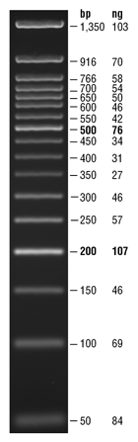
Sample __________ _________ _________ __________ __________
New England BioLabs (NEB) Quick-Load® 50 bp DNA Ladder

___ 8. Run the gel for 30 minutes

(During the incubation begin working on the Introduction to Hardy Weinberg equations - worksheet)

NOTE: If positive and negative PCR controls were set up in laboratory session 2 these may be added to the gel. The positive control (TT) should be subjected to HaeIII digestion as above before gel electrophoresis to confirm that the enzyme is working properly. Your instructor will provide more information on whether to include these samples.

Phenotype - PTC Taste Test

Place the PTC strip on your tongue for 5 sec. Does it taste bitter or like wet paper?

Your phenotype _____________________________

Does it match your initial hypothesis? __________

Anticipated genotype results:

Will your PCR product be digested by the HaeIII enzyme? ______________

What is the anticipated result for the sequencing analysis? ___________________
(Anticipated nucleotide(s) at TAS2R38 base145)

Genotyping - Analysis of Sanger Sequence Results

1. An electropherogram containing your sequence data will be handed out to you (example below).
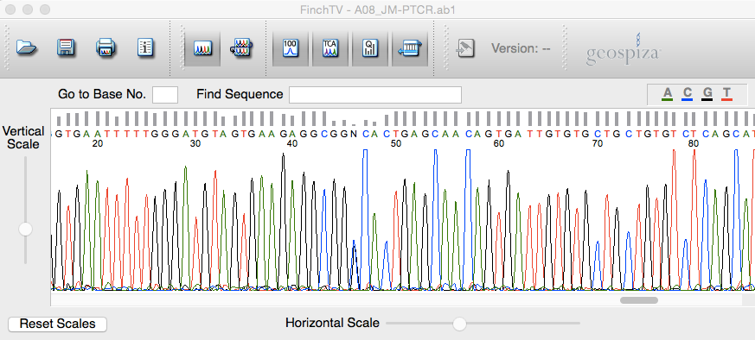
Figure 4 - Electropherogram

Figure 4 - The electropherogram above is from a TAS2R38 heterozygote (Tt). The N
at position 46 on the sequence corresponds to base 145. If you look closely you can
see both a black and a blue peak below the N corresponding to the G in the Taster
allele (T) and the C in the non-taster allele (t).

2. In order to sequence the SNP, which is adjacent to the forward primer, the reverse primer was used for sequencing.

3. Your instructor will walk you through the process of analyzing the electropherogram in FinchTV and demonstrate how to use the integrated BLAST (Basic Local Alignment Search Tool) for identifying and comparing sequences. Once you analyze your sequence answer the questions below.
Based on your sequencing analysis what is your genotype? _______________

Which amino acid(s) would be found at position 49 in your TAS2R38 protein? ________

Bonus Question – What do you know about the two possible amino acids at position 49 that could lead to structural/functional differences in the protein?

Genotyping – Gel Analysis of Restriction Enzyme Digestion

Do you still have the 221bp product in the lane for your digested sample? __________

Is there a 177 bp fragment in your digest sample? __________

Compare your undigested and digested samples. What is your genotype? __________

Comparing All Your Data

Do your sequencing and restriction digest results match? __________

If no, what are some possible reasons for the differences?

Is your genotype what you expected based on your phenotype? __________

If no, what are some possible reasons for the differences?

Are you homozygous or heterozygous? _____________________________

What are possible genotypes for your parents? _____________________________

Fill in the Punnett Square for two heterozygous parents (Tt):

Female
Male

Can you determine from your genotype if your children will be tasters? Explain.

If the other biological parent is a non-taster what percentage of your children would be tasters? And non-tasters?

Applying Your Knowledge

1) Mary performed the same experiments. She is phenotypically a taster, which matched her hypothesis. Her sequence analysis showed that she is heterozygous (Tt).

What results would she expect from her HaeIII restriction enzyme digestion and gel analysis?

When she looked at her gel she saw a 221bp fragment and no other fragments. Is this what she should expect?

If not, what could be some reasons for the difference?

2) Reproducibility in science is important for the progression of science. How can using multiple methods in experimentation help with this?

3) Jenna and her classmate Jonathan compared their genotypes and they are both homozygous tasters. Jenna did not like the taste of the PTC strip but could tolerate it while Jonathan spit out the strip immediately and had to leave the lab to get a drink.

Can you offer some explanations for the phenotypic differences between Jenna and Jonathan?

References

Blakeslee, A. F. (1932). Genetics of Sensory Thresholds: Taste for Phenyl Thio Carbamide. Proceedings of the National Academy of Sciences of the United States of America, 18(1), 120-130.
Bufe, B., Breslin, P. A. S., Kuhn, C., Reed, D. R., Tharp, C. D., Slack, J. P., . . . Meyerhof, W. (2005). The Molecular Basis of Individual Differences in Phenylthiocarbamide and Propylthiouracil Bitterness Perception. Current biology : CB, 15(4), 322-327. doi: 10.1016/j.cub.2005.01.047
Drewnowski, A., Henderson, S. A., & Barratt-Fornell, A. (2001). Genetic taste markers and food preferences. Drug Metab Dispos, 29(4 Pt 2), 535-538.
Floriano, W. B., Hall, S., Vaidehi, N., Kim, U., Drayna, D., & Goddard, W. A., 3rd. (2006). Modeling the human PTC bitter-taste receptor interactions with bitter tastants. J Mol Model, 12(6), 931-941. doi: 10.1007/s00894-006-0102-6
Fox, A. L. (1932). The Relationship between Chemical Constitution and Taste. Proceedings of the National Academy of Sciences of the United States of America, 18(1), 115-120.
Henkin, R. I., & Gillis, W. T. (1977). Divergent taste responsiveness to fruit of the tree Antidesma bunius. Nature, 265(5594), 536-537.
Kim, U. K., Jorgenson, E., Coon, H., Leppert, M., Risch, N., & Drayna, D. (2003). Positional cloning of the human quantitative trait locus underlying taste sensitivity to phenylthiocarbamide. Science, 299(5610), 1221-1225. doi: 10.1126/science.1080190
Laaksonen, O., Ahola, J., & Sandell, M. (2013). Explaining and predicting individually experienced liking of berry fractions by the hTAS2R38 taste receptor genotype. Appetite, 61(1), 85-96. doi: 10.1016/j.appet.2012.10.023
Neff, M. M., Neff, J. D., Chory, J., & Pepper, A. E. (1998). dCAPS, a simple technique for the genetic analysis of single nucleotide polymorphisms: experimental applications in Arabidopsis thaliana genetics. Plant J, 14(3), 387-392.
QIAamp DNA Mini And Bolld Mini Handbook (Qaigen, ed. 3, 2012), pp36-38.
Roberts, R. J. (2005). How restriction enzymes became the workhorses of molecular biology. Proc Natl Acad Sci U S A, 102(17), 5905-5908. doi: 10.1073/pnas.0500923102
Sandell, M. A., & Breslin, P. A. S. (2006). Variability in a taste-receptor gene determines whether we taste toxins in food. Current Biology, 16(18), R792-R794. doi: http://dx.doi.org/10.1016/j.cub.2006.08.049
Sanger, F., Nicklen, S., & Coulson, A. R. (1977). DNA sequencing with chain-terminating inhibitors. Proceedings of the National Academy of Sciences of the United States of America, 74(12), 5463-5467.
Tan, J., Abrol, R., Trzaskowski, B., & Goddard, W. A., 3rd. (2012). 3D structure prediction of TAS2R38 bitter receptors bound to agonists phenylthiocarbamide (PTC) and 6-n-propylthiouracil (PROP). J Chem Inf Model, 52(7), 1875-1885. doi: 10.1021/ci300133a
Tharp, C. D., Tharp, A., Alarcon, S. M., Reed, D. R., & Breslin, P. A. (2005). PTC non-tasters find the fruit of Antidesma bunius bitter, while PTC tasters find it sweet. Paper presented at the Proceedings of the Association for Chemoreception Sciences Sarasota, FL.
VanEtten, C. H. (1969). Goitrogens. In I. E. Liener (Ed.), Toxic Constituents of Plant Foodstuffs (pp. 103–142). New York: Academic Press.
Wooding, S. (2006). Phenylthiocarbamide: A 75-Year Adventure in Genetics and Natural Selection. Genetics, 172(4), 2015-2023.
Wooding, S., Kim, U.-k., Bamshad, M. J., Larsen, J., Jorde, L. B., & Drayna, D. (2004). Natural Selection and Molecular Evolution in PTC, a Bitter-Taste Receptor Gene. American Journal of Human Genetics, 74(4), 637-646.

