Student Handout
Fruit Fly Ethomics & Genomics

Summary of Laboratory Exercise
In this laboratory unit, students will connect behavioral phenotypes to their underlying genes and molecules in the model genetic system, Drosophila melanogaster.

Students will:
- Observe and characterize how male and female fruit flies interact with each other in a mating arena by constructing an ethogram.
- Query a particular mating behavior in the model organism database, FlyBase, to identify candidate genes that are known to code for a particular trait.
- Describe detailed attributes of two chosen candidate genes, including their length, gene structure (e.g., exon/introns), number of transcripts, and expression location (e.g., tissues, embryonic stage, etc.)
- Develop new functional hypotheses on how the two genes contribute to the phenotypic expression of their selected behavior.

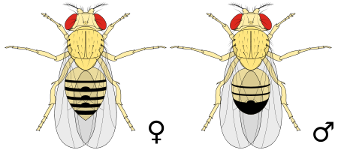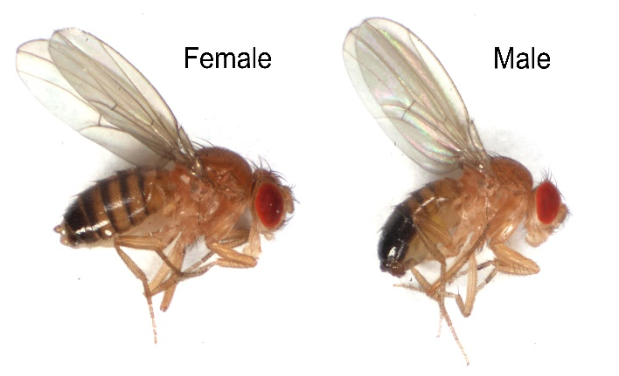

Figure 1. Pairs of Drosophila melanogaster (female on the left and male on the right).

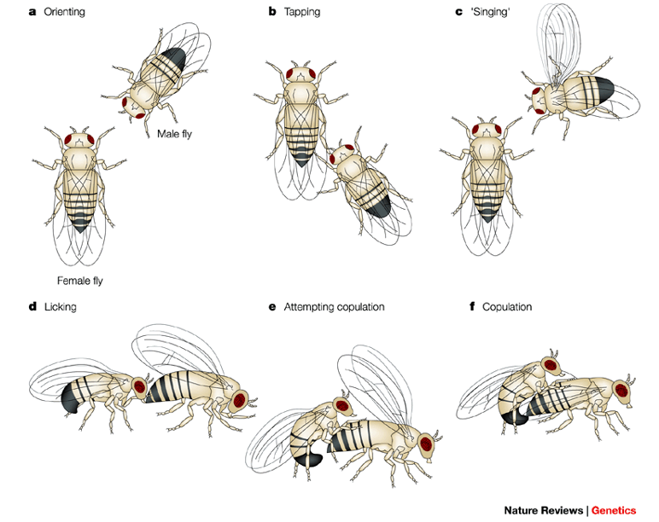
Figure 2. Fruit fly courtship behaviors (taken from Sokolowski 2001).

 | Behaviors | Frequency of behavior | Description of behavior
A | Orienting  (GO:0016543)
B | Tapping  (GO:0016544)
C | Male song  (GO:0045433)
D | Male licking  (GO:0008049)
E | Following/chasing  (GO:0016546)
F | Copulation  (GO:0007620)

Behavioral Observation Worksheet (Part 1)

With your lab partner, open a browser on your computer and go to (or paste in) the YouTube URL that was assigned by your instructor. The 15 minute video will comprise of five males and five females. Be sure that you are able to distinguish between the sexes. You will be constructing a basic “ethogram” that quantifies behavioral activity in the arena by recording the frequency of successive events. Record any mating behaviors (refer to Figure 2) on the observation worksheet, below, including the frequency of each behavior (use ticks or check marks). Briefly define each of the behaviors after the observation period in your own words. If you observe a mating behavior that is not pre-defined in Figure 2, describe it and the number of observations in an unlabeled row. In the exercise, each behavior should be treated as a continuous event separated from other events or periods of inactivity. Gene Ontology (GO) IDs of each behavior are provided for Part 2.
Ethogram
Share the final tally of your observations per behavior with your class on the blackboard.

Questions on courtship behaviors

- What was the most frequent courtship behavior(s) observed in the flies?
______________________________________________________________
________________________________________________________________

ii. In this exercise, you recorded the frequency of events and not their duration time. Can you think of another method to quantify behavioral observations?
________________________________________________________________
________________________________________________________________

iii. In the space below hand-draw a bar graph that compares the frequency of mating behaviors that you observed in your 15 minute video.

Frequency

Orienting Tapping Singing Chasing Licking Copulation

iv. How reproducible were your observations? For example, do other groups have similar observations, in terms of the relative frequencies of behaviors? From the class results on the blackboard, calculate the average number of observations in each behavior per group (total observations per behavior divided by the number of lab groups) and add this to the above bar graph using another color.
________________________________________________________________
________________________________________________________________

v. Select a specific mating behavior from Figure 2 that you would like to further examine, in terms of its genetic basis. In the next part of this lab, you will identify genes involved in this behavioral phenotype and characterize their function from a molecular perspective.
Mating behavior: __________________________________________________
Exploring FlyBase (Part 2)

FlyBase is an online biological database designed primarily for researchers studying the model genetic organism, Drosophila melanogaster, and related fruit fly species. FlyBase contains an enormous number of tools and data, and it is very easy to get disoriented. Using a morphological phenotypic mutation, we will first walk you through FlyBase to demonstrate how to quickly navigate through its remarkable array of resources. At the end of this exercise, you will select one of the courtship behaviors you observed in the previous exercise and use FlyBase to characterize two of its “candidate” genes, i.e., genes that may contribute to a particular behavioral phenotype. Once you complete your Candidate Gene Worksheet (last page of this handout), we encourage you to further explore FlyBase and its many links.
To identify genes that encode a particular phenotype, we will search FlyBase’s library of functional ontologies. These gene ontologies have been defined by experts in the community and provide geneticists with a common dictionary of phenotypes that can be connected to individual genes via richly curated data from Drosophila's extensive genetic and phenotypic literature base. In today’s lab, we will search ontological classes based on known genetic mutations.
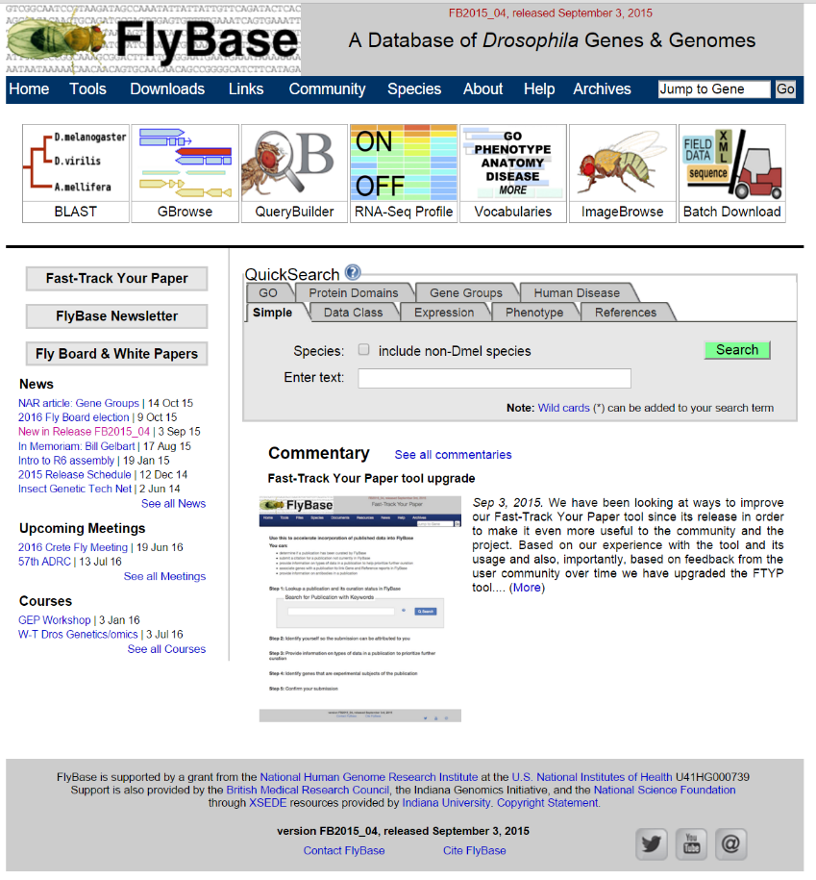
1. Go to FlyBase
On your computer, open a web browser and go to “www.flybase.org”. The FlyBase homepage should look like the image on the right.
In Part 1, you identified a behavioral phenotype that you wanted to study further. However, in this demonstration, we will focus on a known complex morphological trait: the lack of female genitalia. Once you are done, your instructor will provide an answer key based on the latest version of FlyBase (FB2015_04): Of course, due to regular FlyBase updates, values will change.
The process for identifying the genes responsible for this particular phenotypic trait will be similar for addressing the genetic basis of any fruit fly trait you wish to study via FlyBase.

2. Choose the correct ontological category and associated controlled vocabulary
On the FlyBase homepage, click the “Vocabularies” toolbox at the top of the page (it is the box labeled with the text “GO, Phenotype, Anatomy, More”). This will bring you to the “Vocabularies Search Page”.

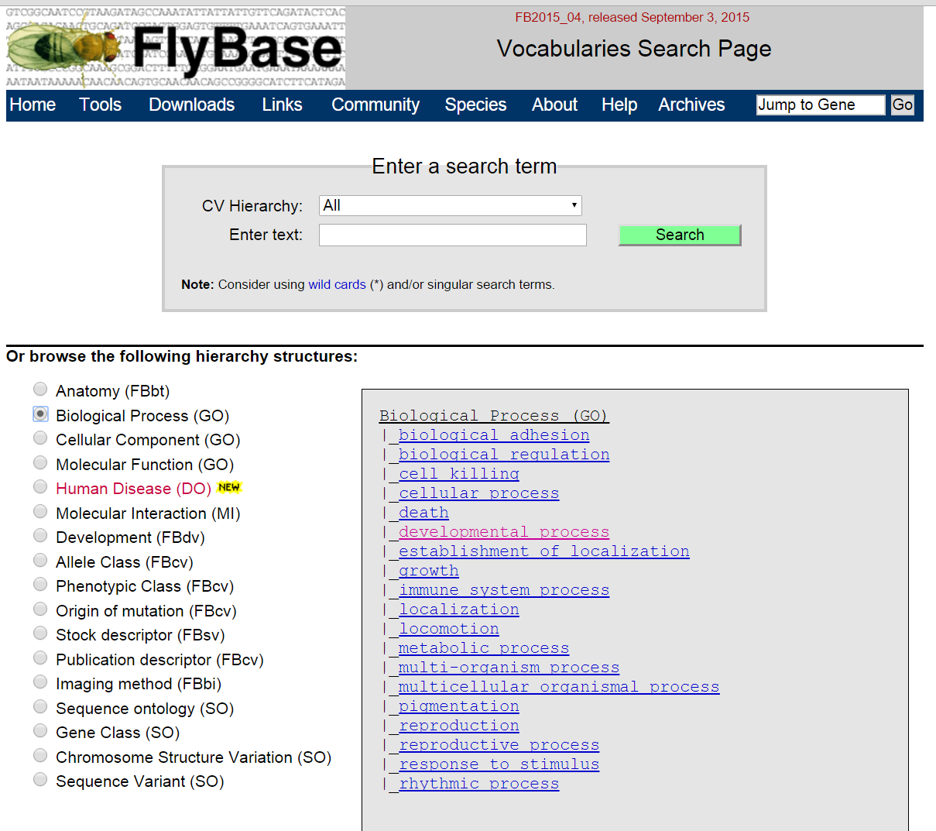
On the left hand side, select the “Biological Process (GO)” radio button (indicated, in the above figure, in the green oval). This particular ontological class accesses Drosophila Gene Ontologies (GO), a well-curated dictionary of fruit fly phenotypes. Once you select a particular ontological class, there are many ontological subcategories, also known as Controlled Vocabularies (CVs), that you could choose from and they are organized in a hierarchical “Spanning Tree”. Each CV will be associated with genes that have been curated from the Drosophila community’s extensive literature. Navigating through the submenus will reduce the number of gene hits for each term until you find a particular gene of interest.
On the right hand side of the page (in the grey box indicated by the red arrow in the above figure), you will need to choose the term that best describes the phenotype that we wish to study its genetic basis, in this case, a female fly lacking genitals.
Scanning the list of available ontological terms under “Biological Process (GO)”, what do you think is/are the most appropriate term(s) to click with respect to this particular morphological phenotype of interest?
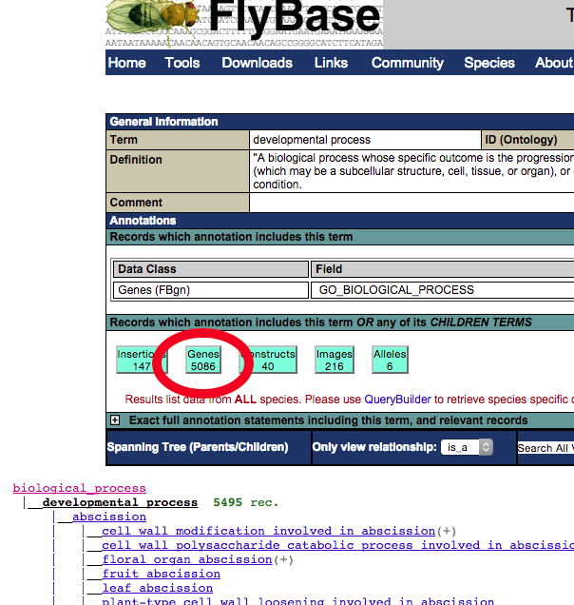
_____________________________________________________________(a)

The absence of female genitalia phenotype would likely be under “developmental process”. Click this term and the “Term Report” page appears (see figure on left). The teal blue boxes” provide the number of records available for this parent CV and any of its child ontologies. Clicking on the “Genes” box (circled in red on the lefthand figure) will bring you to an alphabetized list of all the genes that are associated with this term. Scroll down past the numbered genes.

How many genes are associated with “development process”?
_____________________________________________________________(b)

List three gene names with their associated symbols.
_____________________________________________________________(c)
Obviously, here these are too many gene records to individually sort through. So, let’s further narrow our search. Navigate back to the previous page, using the browser’s back button. Below the records box, you will see a hierarchical “Spanning Tree”, a very long list of CVs that are classified as “development process” (see above figure). You will have to use some logic and thought to narrow things down, but in the interest of time, do the following: under the child term “anatomical structure development ” (since the genitals appeared to never have formed correctly this was probably a developmental process) you should see the term, “analia development”. Click on this term. Now, click the term, “female analia development”. There should be ~2 genes: certainly a much more manageable list of genes to explore.
( 3 )
( 4 )

3. Choose a gene(s) that codes for this particular phenotype

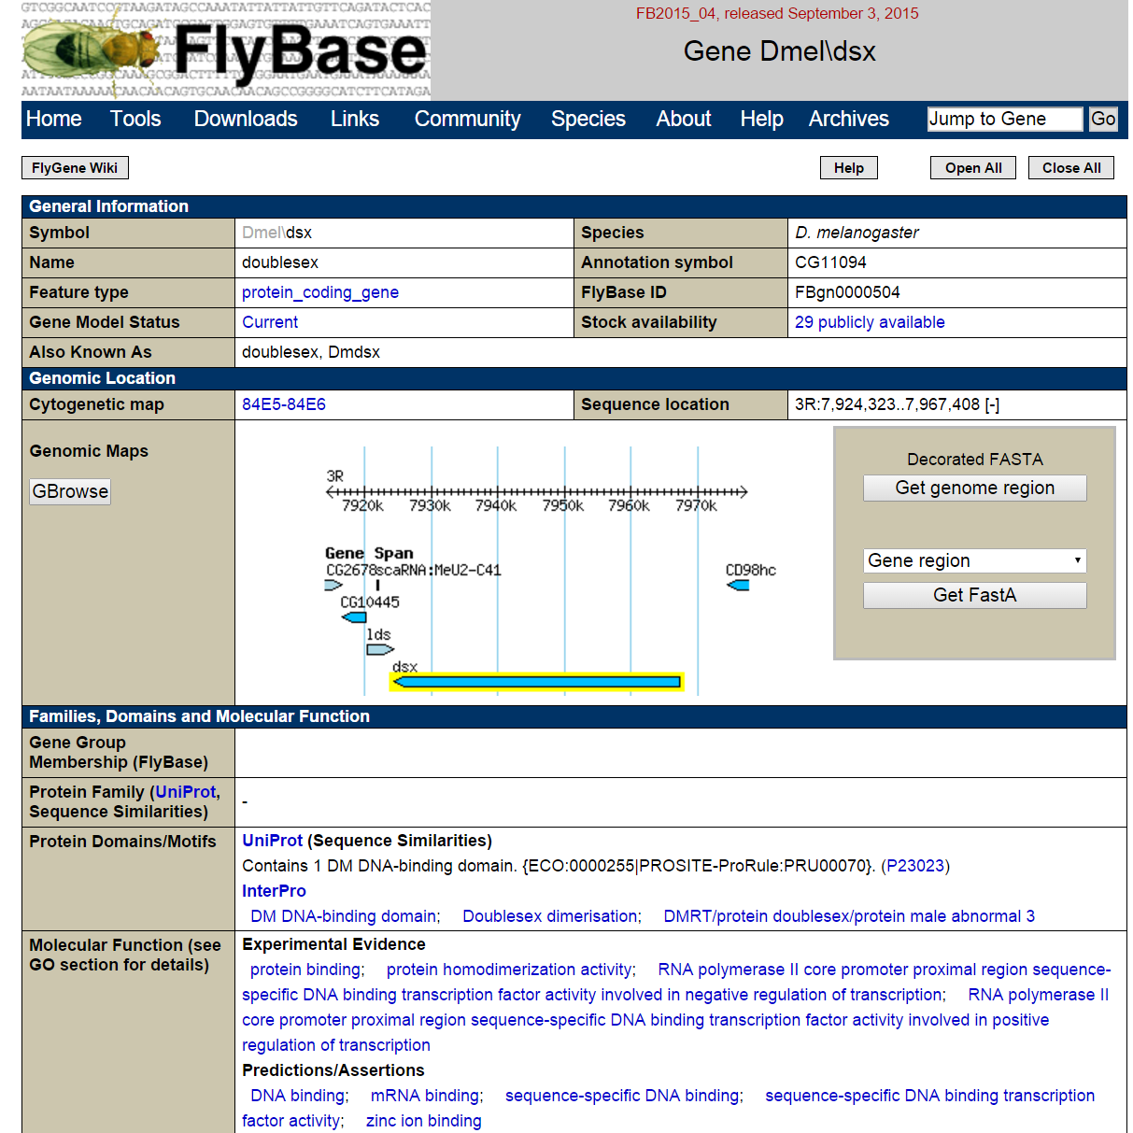
Click on the “Genes” box. The genes, “doublesex” and “ken and barbie” should be listed. From their gene names, guess which gene has a phenotype that does not develop external genitalia.
( 3 )
( 1 )
( 2 )
( 4 )
Click the ken gene. ken is the gene symbol for ken and barbie. Above is their “Gene Page”. There is an enormous amount of information about that gene here including (labeled in red in the figure above): the species and symbol (1), sequence location (2), and a map of the immediate genomic region (3), evidence-based molecular functions (4) and a summary of the gene’s known functionality are also included if you open the boxes below the Genomic Map. Refer back to your observational data to help understand the molecular basis of the chosen behavior.

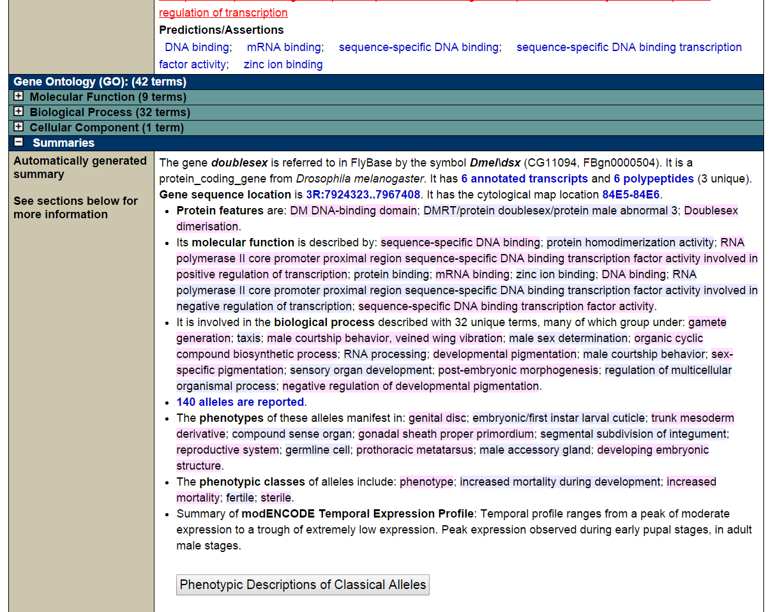
Click open the “Summaries” tab (circled in red, above) and you will be presented with curated information about this particular gene. For our purposes, the most informative section is the “Phenotypic Description of Classical Alleles” button at the bottom of the first summaries box (also circled in red, above) presenting a compilation of the extensive and curated Drosophila literature. Click it.
From the enormous literature generated by the Drosophila community over the last century, observed mutant phenotypes have been collected and curated by FlyBase. A separate description for each observed mutant phenotype of ken is listed in each row. In Drosophila, an allele is usually denoted in superscript after the gene symbol but in databases with character type restrictions, they are typically denoted in square brackets (e.g., ken[00628]). Alleles are specific versions of a gene. Geneticists typically generate non-functional gene versions to study their effect on the organism.
Summarize one of the ken phenotypes in your own words (pick any one):
________________________________________________________________
______________________________________________________________(d)
How many different alleles of ken have been studied in the Drosophila literature? [Hint: count the rows or number of “Submitted IDs”] Remember, ken is only one of ~14,000 genes in D. melanogaster: lots of research has been performed on this insect.
______________________________________________________________(e)
4. Explore the molecular and functional features of this gene
Going back to the Summaries section, you should see a bullet that says “The phenotypes of these alleles manifest in”. This section lists the specific tissues where this phenotype is detected.
List the tissues in which this phenotype is expressed that supports your hypothesis of this gene’s function.
______________________________________________________________(f)
_______________________________________________________________
Under the “General Information” section found at the top, we find basic data about the gene including the Gene Symbol which is represented as
“species\symbol”. “D” stands for Drosophilia and “mel” for melanogaster, and ken is the official gene symbol denoting the “ken and barbie” gene, i.e., Dmel\ken.
Why do you think this name was chosen for this gene?
______________________________________________________________(g)
________________________________________________________________
You should also see the FlyBase ID in this section, “FBgn0011236”. This represents the unique identifier assigned to each gene on FlyBase. You can use this FlyBase ID or the symbol to look up the gene if you need to refer to it later.
What type of gene is this? [Hint: look in “Feature type”]
______________________________________________________________(h)
Under the “General Information” section is the “Genomic Location” section. The first thing you should notice is the “Sequence location”. The ken gene is on the right arm of the second chromosome (2R) on the positive strand (+).
How large is the ken gene? [Hint: subtract the two numbers in “Sequence location”]
______________________________________________________________(i)
Also displayed is a snapshot of a genomic map that details genes, their content, and their position in the genome. Next to the genomic map are links to download the actual gene sequence in FASTA format for other analyses (like a BLAST search). Perhaps, the most powerful tool is the “GBrowse” link on the left hand side of the gene map. This takes you to a genome browser to visualize the Dmel/ken locus. Click on it. Identify the Landmark section and the Gene Span and Transcript tracks.
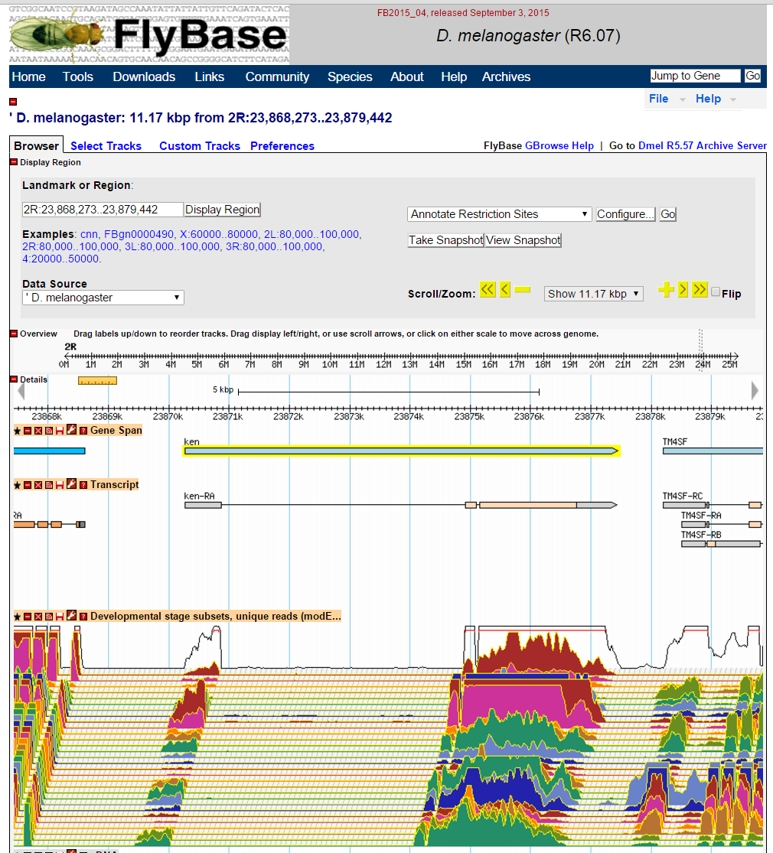
The “Transcript” track provides gene models including UTRs (grey rectangle), exons (orange rectangle), and introns (black line). Draw ken’s gene model below.
______________________________________________________________(j)

Scroll down to the “Developmental stages subsets…” (in red oval, in figure above) tracks and you will see a multi-colored series of graphs that span this genomic region. Each of the color-coded graphs represents the gene expression level for a specific developmental stage. If you mouse-over the graphs (or click the little wrench in the track label, circled in green in figure above), you will see the color-coded legend denoting transcriptomic levels from stages 0-2hrs in the embryo (em0-2hr) to the third larval instar (L3_12hr) to adult females 30 days after hatching (AdF_Ecl_30days). These graphs refer to the “Temporal Expression” of each gene/transcript and represent the unprecedented “big data” that is currently being generating in genomics. It is easy to see that ken is expressed in only certain developmental stages. Note that only exonic regions are expressed—compare the location of these graphs to the gene models found in the Transcript tracks.
For a better view, again, click on the little wrench in the track label located just above the transcriptomic tracks. When the settings menu pops up under the “Signal scaling method”, set it to “linear”. Hitting “Apply Changes” will close this box and redraw the graphs of gene expression as linear values. With these settings you should be able to see more clearly how expression levels change at different points during development. From this new view, which specific developmental stages have the highest and/or most consistent expression levels across exons? [Hint: three of them are circled in yellow, in the above figure.]
______________________________________________________________(k)
Since the phenotypic trait we are studying (lack of female genitalia) is associated with development, it is most likely expressed during certain points in the life cycle of the fly. Using these data, we can see when in the life cycle a specific gene is expressed and get a better idea of its function. This information is available for all genes and, in fact, the entire genome of D. melanogaster. Using these expression data, what can you hypothesize about the function of the gene, ken, and its observed phenotype (lack of proper female genitalia)?
______________________________________________________________(l)
Which gene is ken’s immediate 3’ downstream neighbor, and how many alternative transcripts does this gene appear to have?
______________________________________________________________(m)
Explore some of the other tracks. As you can see, we have so much fine-grained information concerning the genome of fruit flies. These little critters are considered pests to most non-geneticists yet, for over a century, they have been the go-to organism for genetic studies. Why do we spend so much time and energy to learn so much about this tiny insect? Use a few minutes to think about this question and then write down your thoughts in a few sentences.
______________________________________________________________(n)
________________________________________________________________
________________________________________________________________
________________________________________________________________
________________________________________________________________
________________________________________________________________
________________________________________________________________
Take some time to explore the genomic landscape you see here by playing with the zoom size and then exploring the wide range of tracks. If at any point you get lost all you have to do is hit the back button on your web browser and it will take you back to the Gene Page. Then, simply navigate to the GBrowse page again. The tools and resources you see on FlyBase are typical of most model organism databases (MODs) as well as major human databanks such as NCBI and the UCSC Genome Browser, so you have now learned how to access the amazing world of genomic data!

Behavioral Candidate Gene Worksheet (Part 2)

Which behavioral phenotype (from Part 1) did you choose to study further?

____________________________________________________________
Using FlyBase’s extensive database of ontological “Vocabularies”, identify a number of genes identified in “Biological Process (GO)” for your selected behavioral phenotype. Exploring phenotypic descriptions will help to evaluate whether a gene is a candidate for your behavioral phenotype of interest. If the description does not match your observations, it is not a strong candidate (at least, without further experimentation). However, if you see a description that matches your observations, then you have found an ideal candidate gene for your behavioral phenotype.
After you have identified two potential candidate genes, complete the worksheet. Include a brief hypothesis on how this gene may have molecularly contributed to your chosen courtship behavioral phenotype.

1. Gene name: _____________________________________________
Gene symbol: ______________ Genomic location:______________
Gene size (bps):_____________ Protein size (amino acids):_______
Number of exons:____________ Number of transcripts:___________
Hypothesis on the molecular basis of behavioral phenotype:
_____________________________________________________________
_____________________________________________________________
_____________________________________________________________
_____________________________________________________________

2. Gene name: _____________________________________________
Gene symbol: ______________ Genomic location:______________
Gene size (bps):_____________ Protein size (amino acids):_______
Number of exons:____________ Number of transcripts:___________
Hypothesis on the molecular basis of behavioral phenotype:
_____________________________________________________________
_____________________________________________________________
_____________________________________________________________
_____________________________________________________________

3. By looking at when and where these genes are expressed, is it possible that these two genes (or their expressed proteins) interact to generate the mating behavior?
_____________________________________________________________
_____________________________________________________________
_____________________________________________________________
_____________________________________________________________

